**Predicting the readmission of patients within 30 days**

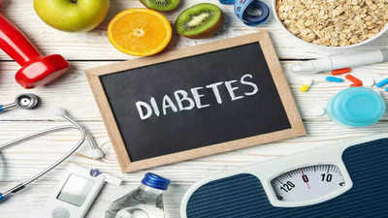

* **Introduction**

Diabetes is a chronic disease where a person suffers from an extended level of blood glucose in the body. Diabetes is affected by height, race, gender, age but a major reason is a sugar concentration. The present analysis of a large clinical database was undertaken to examine historical patterns of diabetes care in patients with diabetes admitted to a US hospital and to inform future directions which might lead to improvements in patient safety. Reducing early hospital readmissions is a policy priority aimed at improving healthcare quality. In this case study we will see how machine learning can help us solve the problems caused due to readmission.

* **Objective**

The primary objective of analysing the dataset is to understand the factors that contribute to high readmission rates of diabetic patients within 30 days post discharge and to develop strategies to improve patient outcomes and reduce readmission rates. And, to identify the medicines that are most effective in the treatment.

* **Business Problem and Constraint**

It is estimated that 9.3% of the population in the United States have diabetes, 28% of which are undiagnosed. The 30-day readmission rate of diabetic patients is 14.4 to 22.7%. Estimates of readmission rates beyond 30 days after hospital discharge are even higher, with over 26 % of diabetic patients being readmitted within 3 months and 30 % within 1 year. Costs associated with the hospitalization of diabetic patients in the USA were $124 billion, of which an estimated $25 billion was attributable to 30-day readmissions assuming a 20 % readmission rate. Therefore, reducing 30-day readmissions of patients with diabetes has the potential to greatly reduce healthcare costs while simultaneously improving care.

**Constraints:**

1. **Interpretability of model is very important:** Interpretability is always important in health care domain if model predict that some patient will readmit but can’t explain why it came to this conclusion the doctor will be clueless about such decision and also doctor won’t be able to tell the patient why he needs to readmit practically it will create lots of inconvenience to doctor as well as patient.
2. **The cost of misclassification is high:** If the patient that doesn’t need to readmit if model says “yes to readmit” that will put financial burden on the patient. If patient need to readmit but model say “no to readmit” then that will cause readmission cost to the hospital so, misclassification rate should be as low as possible.

* **Real World Impact**

Insights from this dataset could lead to improved patient care for those with diabetes, more effective treatment plans, and reduced healthcare costs associated with readmissions. It could also inform public health policies and diabetes education programs to better manage this chronic condition on a larger scale.

* **Data Overview**

The dataset is from UCI machine learning repository. Data represents ten years (1999-2008) of clinical care at 130 US hospitals and integrated delivery networks. Each row concerns hospital records of patients diagnosed with diabetes, who underwent laboratory, medications, and stayed up to 14 days.

**Data Fields:**

Here, we have provided short description of each feature.

1. **Encounter ID:** Unique identifier of an encounter
2. **Patient number:** Unique identifier of a patient
3. **Race** **Values**: Caucasian, Asian, African American, Hispanic, and other
4. **Gender** **Values**: male, female, and unknown/invalid
5. **Age:** Grouped in 10-year intervals: 0, 10), 10, 20), …, 90, 100)
6. **Weight:** Weight in pounds
7. **Admission type:** Integer identifier corresponding to 9 distinct values, for example, emergency, urgent, elective, newborn, and not available
8. **Discharge disposition:** Integer identifier corresponding to 29 distinct values, for example, discharged to home, expired, and not available
9. **Admission source:** Integer identifier corresponding to 21 distinct values, for example, physician referral, emergency room, and transfer from a hospital
10. **Time in hospital:** Integer number of days between admission and discharge
11. **Payer code:** Integer identifier corresponding to 23 distinct values, for example, Blue Cross/Blue Shield, Medicare, and self-pay Medical
12. **Medical specialty:** Integer identifier of a specialty of the admitting physician, corresponding to 84 distinct values, for example, cardiology, internal medicine, family/general practice, and surgeon
13. **Number of lab procedures:** Number of lab tests performed during the encounter
14. **Number of procedures:** Numeric Number of procedures (other than lab tests) performed during the encounter
15. **Number of medications:** Number of distinct generic names administered during the encounter
16. **Number of outpatient visits:** Number of outpatient visits of the patient in the year preceding the encounter
17. **Number of emergency visits:** Number of emergency visits of the patient in the year preceding the encounter
18. **Number of inpatient visits:** Number of inpatient visits of the patient in the year preceding the encounter
19. **Diagnosis 1:** The primary diagnosis (coded as first three digits of ICD9); 848 distinct values
20. **Diagnosis 2:** Secondary diagnosis (coded as first three digits of ICD9); 923 distinct values
21. **Diagnosis 3:** Additional secondary diagnosis (coded as first three digits of ICD9); 954 distinct values
22. **Number of diagnoses:** Number of diagnoses entered to the system 0%
23. **Glucose serum test result:** Indicates the range of the result or if the test was not taken. Values: “>200,” “>300,” “normal,” and “none” if not measured
24. **A1c test result:** Indicates the range of the result or if the test was not taken. Values: “>8” if the result was greater than 8%, “>7” if the result was greater than 7% but less than 8%, “normal” if the result was less than 7%, and “none” if not measured.
25. **Change of medications:** Indicates if there was a change in diabetic medications (either dosage or generic name). Values: “change” and “no change”
26. **Diabetes medications:** Indicates if there was any diabetic medication prescribed. Values: “yes” and “no”
27. 24 different kinds of medical drugs.
28. **Readmitted:** Days to inpatient readmission. Values: “0” if the patient was readmitted in less than 30 days, “>30” if the patient was readmitted in more than 30 days, and “No” for no record of readmission.

* **Performance Metrices**

Our task is a classification problem so we can use performance metrics like precision, recall, Accuracy and F1-score.

There are many metrices available to choose from:

1. Accuracy
2. Precision
3. Recall
4. F1 score
5. ROC and AUC curve

**Metric selection and reasoning:**

1. **Accuracy** is a fundamental metric that provides an overall measure of the model's correctness. In healthcare, accurate predictions are essential to avoid misdiagnoses and ensure that patients receive appropriate treatments.
2. **Precision** is the ratio of true positive predictions to the total predicted positives. In healthcare, precision is crucial when the cost of false positives is high. For example, in cancer diagnosis, high precision ensures that identified cases are more likely to be genuine, reducing unnecessary treatments or interventions.
3. **Recall** measures the ratio of true positive predictions to the total actual positives. In healthcare, recall is essential when the cost of false negatives is high. For instance, in disease screening, high recall ensures that the model can identify a significant portion of actual positive cases, minimizing the chances of missing critical diagnoses.
4. **F1 score** is the harmonic mean of precision and recall, providing a balanced measure that considers both false positives and false negatives. In healthcare, where the balance between precision and recall is crucial, the F1 score is a useful metric to evaluate a model's performance when there is an uneven class distribution or when both false positives and false negatives are impactful.
5. **Receiver Operating Characteristic (ROC) and Area Under the Curve (AUC)** provide a comprehensive evaluation of a model's ability to discriminate between classes. In healthcare, where the trade-off between sensitivity and specificity is important, ROC AUC score is valuable. It helps assess how well the model can distinguish between positive and negative cases across various probability thresholds, providing insights into the model's discriminatory power.

* **Approach and Problem Type**

This is a machine learning problem and binary classification where the goal is to predict whether a person has diabetes or not based on the available health-related features. To do this we have models like Logistic regression, Decision Tree, Random Forest, SVM, to name a few.

**Exploratory Data Analysis (EDA):**

**Importing the libraries NumPy, pandas, matplotlib, and seaborn to do data analysis.**

1. **NumPy:** It is essential for handling numerical data efficiently and performing various mathematical operations.
2. **Pandas:** It provides data structures like Data Frames and Series, which make it easy to handle and analyse structured data.
3. **Matplotlib:** Matplotlib is crucial for visualizing patterns and relationships within the data.
4. **Seaborn:** Seaborn is built on top of Matplotlib and provides a high-level interface for creating attractive and informative statistical graphics.

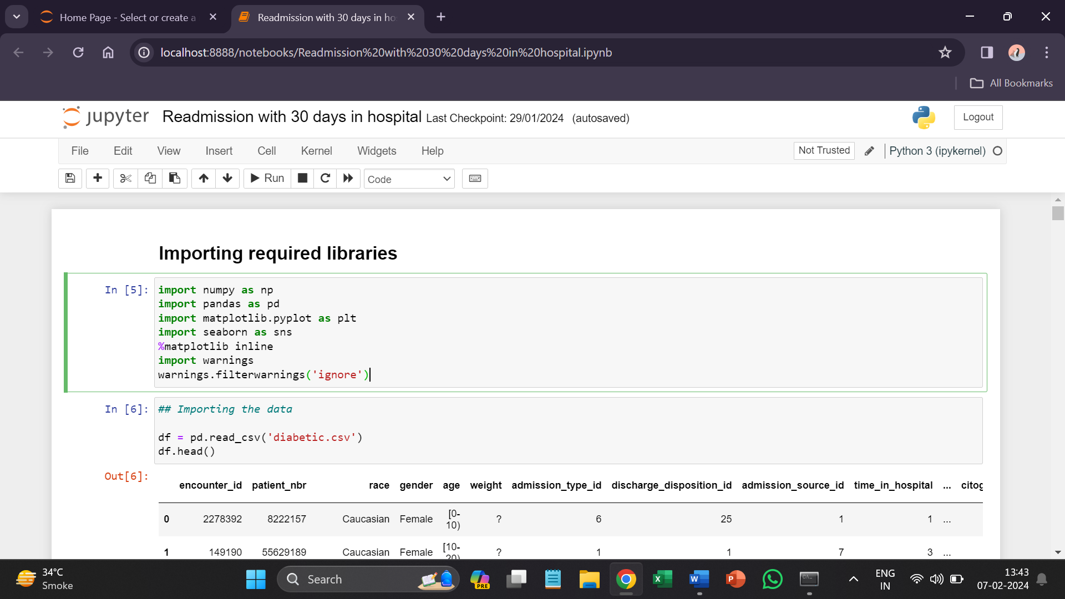

**The first 5 rows of data:**

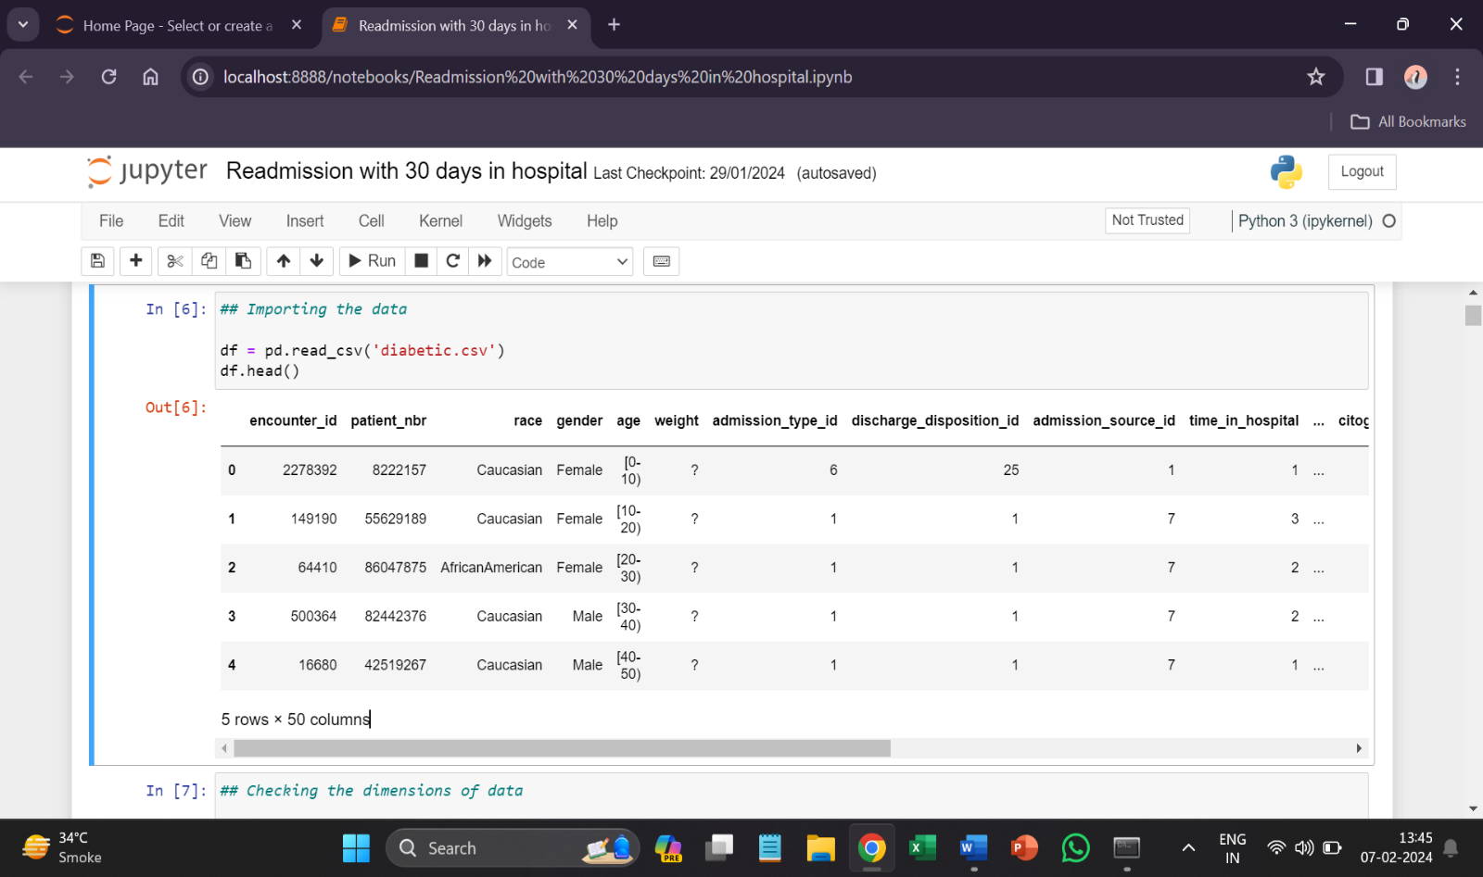

There are **101766** rows and **50** features in the data.

**Checking the null values**

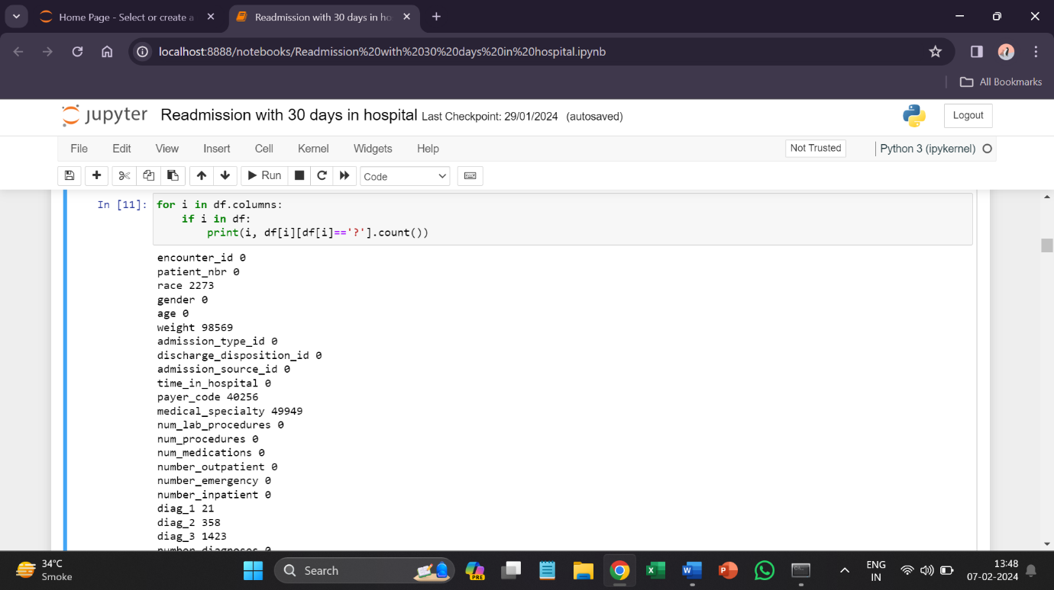

Null values in data are represented as ‘?’. The columns weight, payer code, medical specialty, diag_1, diag_2, diag_3 have null values.

* Weight has **96.85%** missing values so there is no significance of filling those values so I decided to drop this column.
* payer_code has **39.55%** missing values.
* medical_specialty has **49.0%** missing values it has 50% data missing we can fill these ahead as we do analysis.
* **EDA and visualization**

1. **Target variable (Readmitted)**

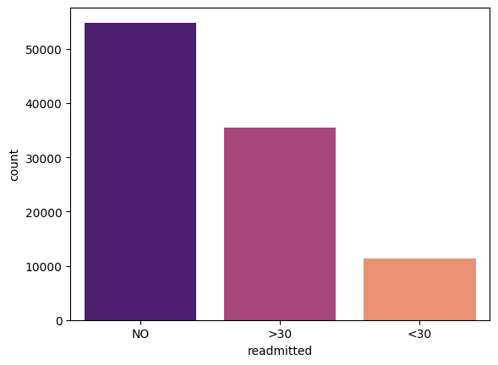

* As approximately, **50%** of data belongs to **NO** class and other classes have less data.
* This will create **imbalance** data problem.
* So, we will take this as **2 class classification** problem.

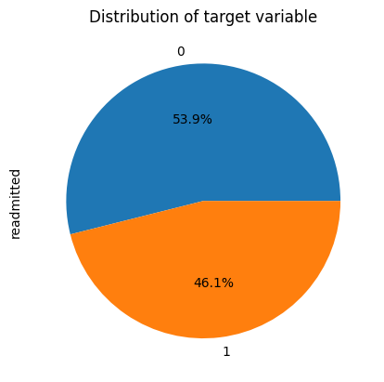

We have taken this as a binary classification task. And we can see that **46%** patients have been readmitted to hospital. Now we will see which features are responsible for this.

1. **Correlation**

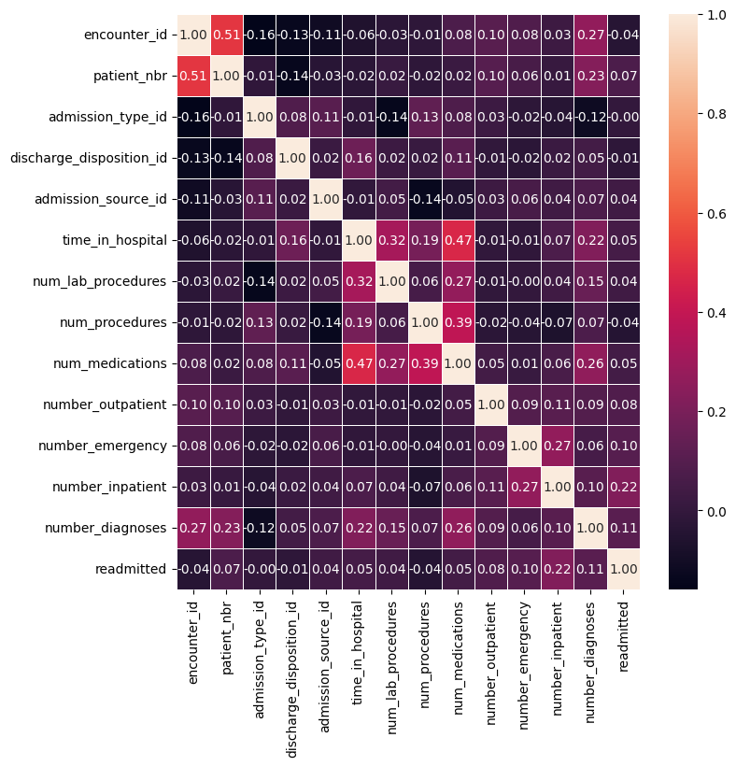

**Observations:**

1) **time_in_hospsital** is highly correlated with discharge_disposition_id.

2) **encounter_id** and **patient_id** is merely a unique identity so we do not care about that.

3) **admission_source_id** has some correlation with **admission_type_id.**

4) **num_procedures** are highly correlated with **num_medication.**

5) **number_emergency** is a little bit correlated with **number_inpatient**.

**Now analysing the independent features to see which is highly responsible for readmission.**

1. **Encounter_id**

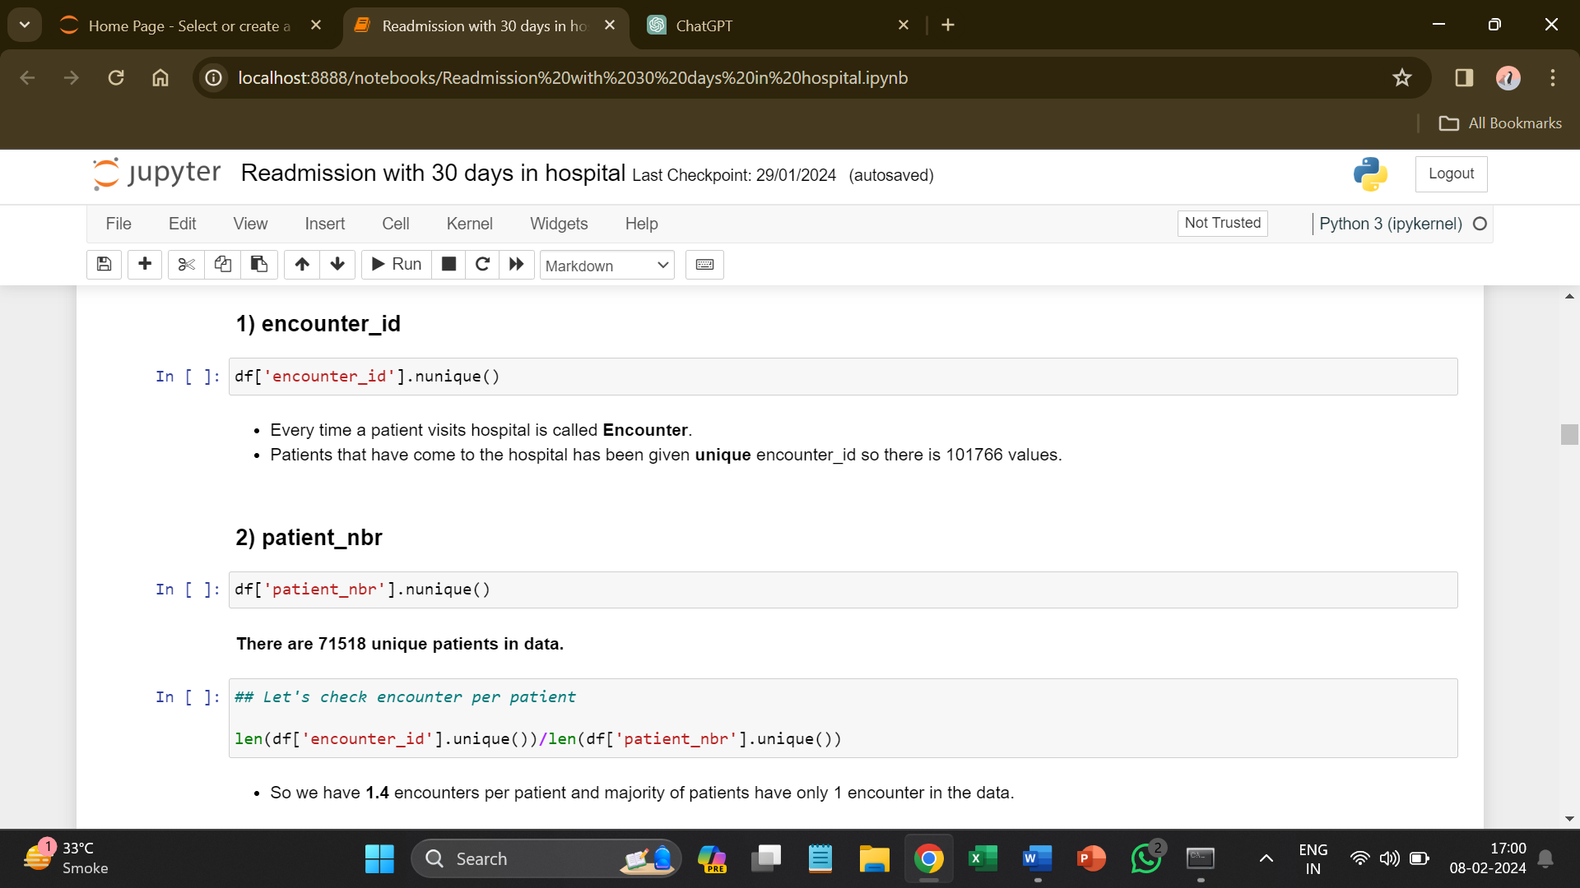

* Every time a patient visits hospital is called **Encounter**.
* Patients that have come to the hospital has been given unique **encounter_id** so there are **101766** values.

1. **Patient_nbr**



* There are **71518** unique patients in data.

1. **Race**

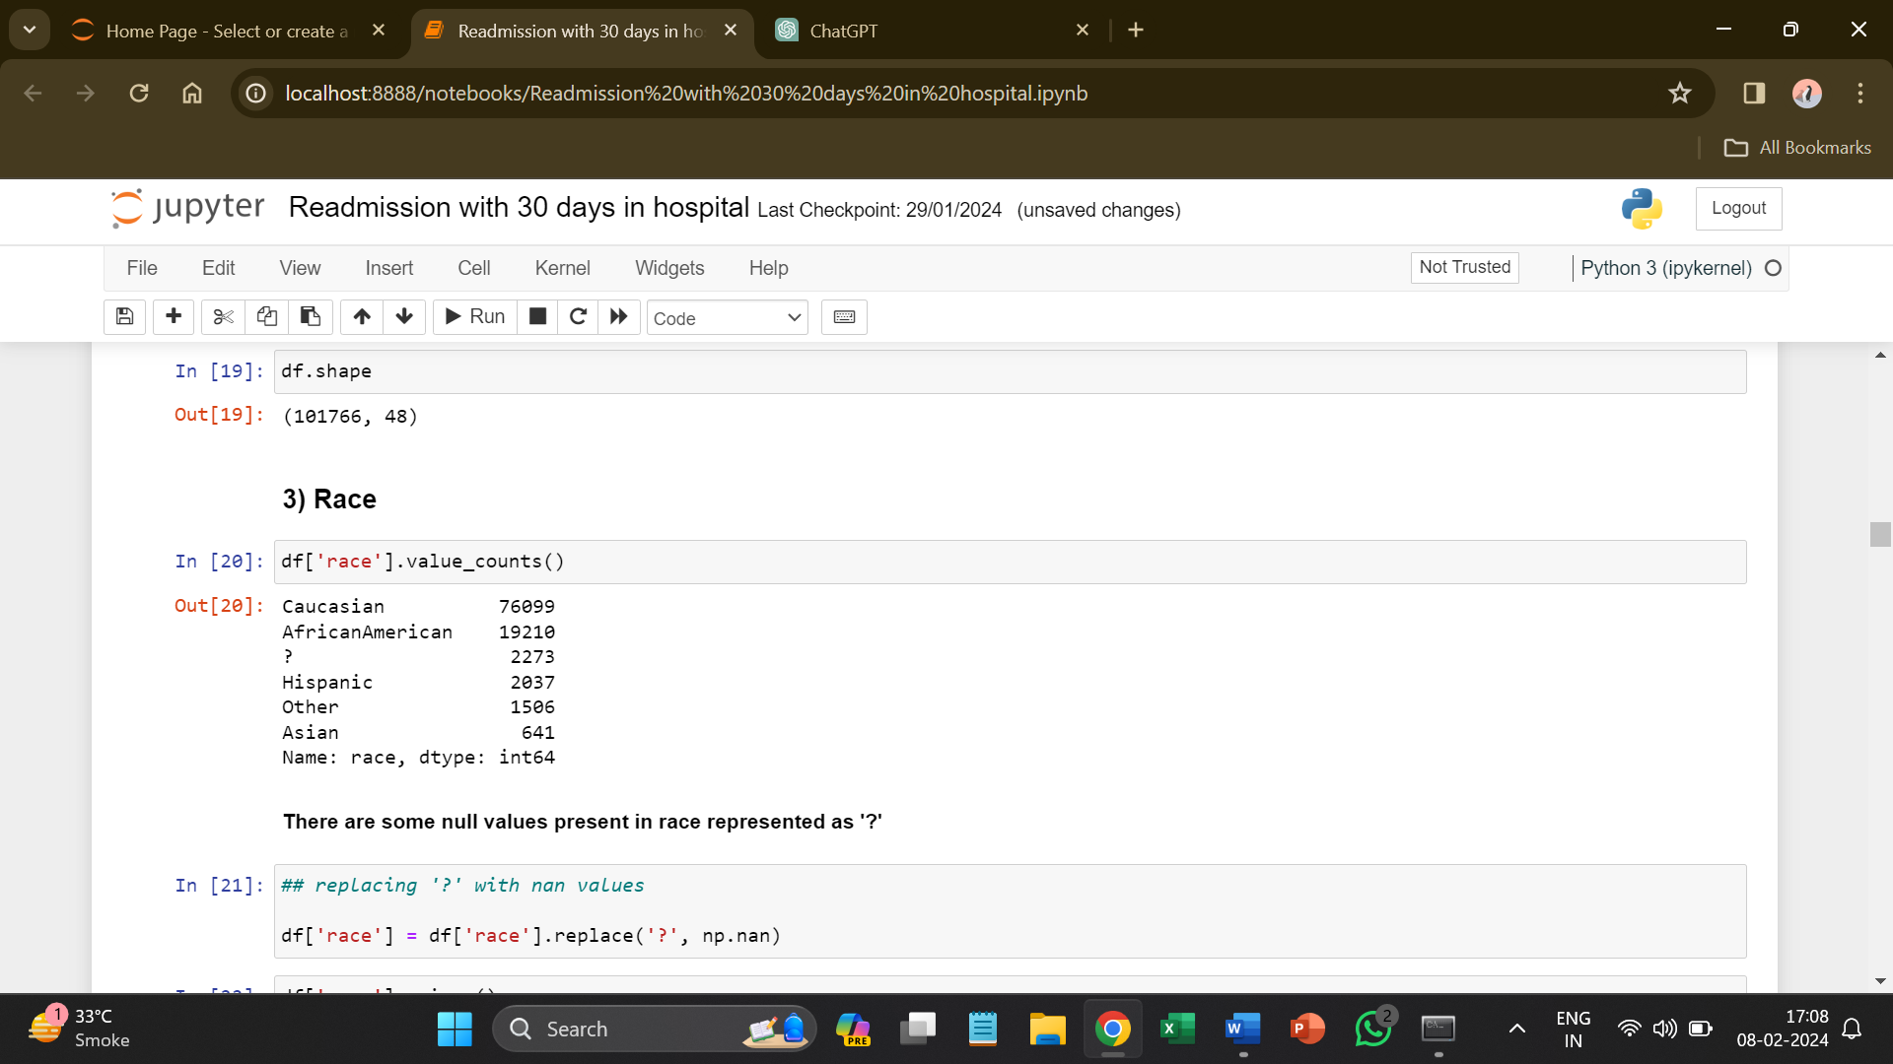

* There are approximate **2273** null values present in race represented as '**?**'.

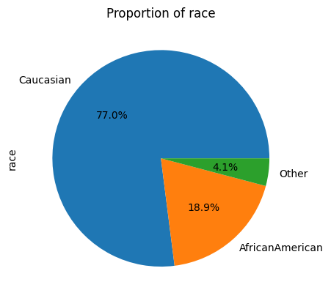

* We can see that majority of cases are **Caucasian (77%)** then **AfricanAmerican (18.9%)**.

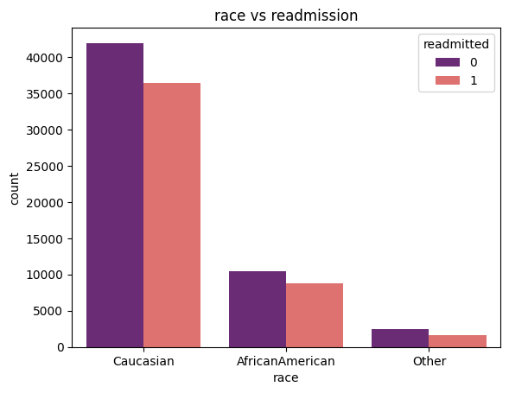

* Most of the patients that have been readmitted have history of **Caucasian** followed by **AfricanAmerican**.

1. **Gender**

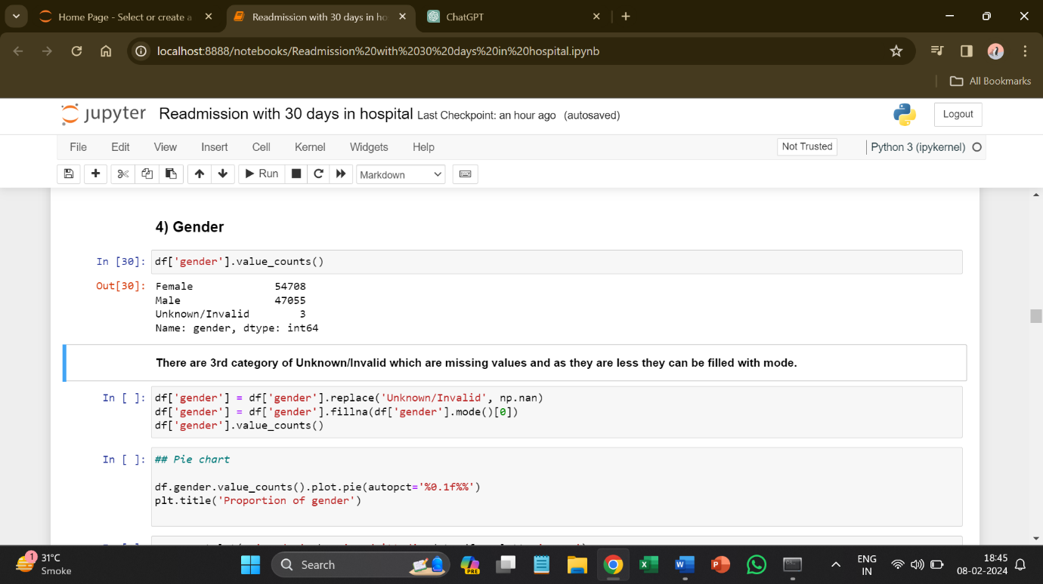

* There are 3rd category of **Unknown**/**Invalid** which are missing values and as they are less, they can be filled with mode.

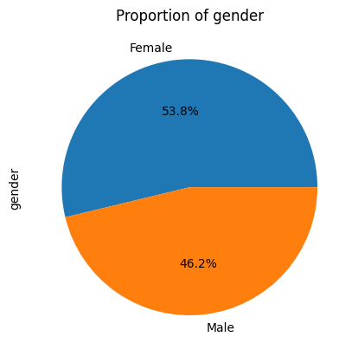

* After filling the missing values with mode this the graph that we got. It has **53.8% female** and **46.2% male**.

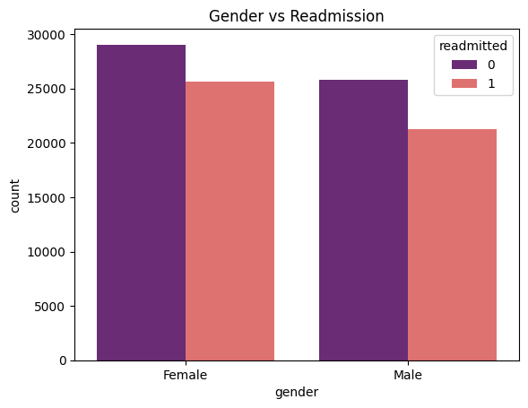

* We can see there is almost **equal distribution** of gender among data.
* Females are little more prone of readmitting than males.

1. **Age**

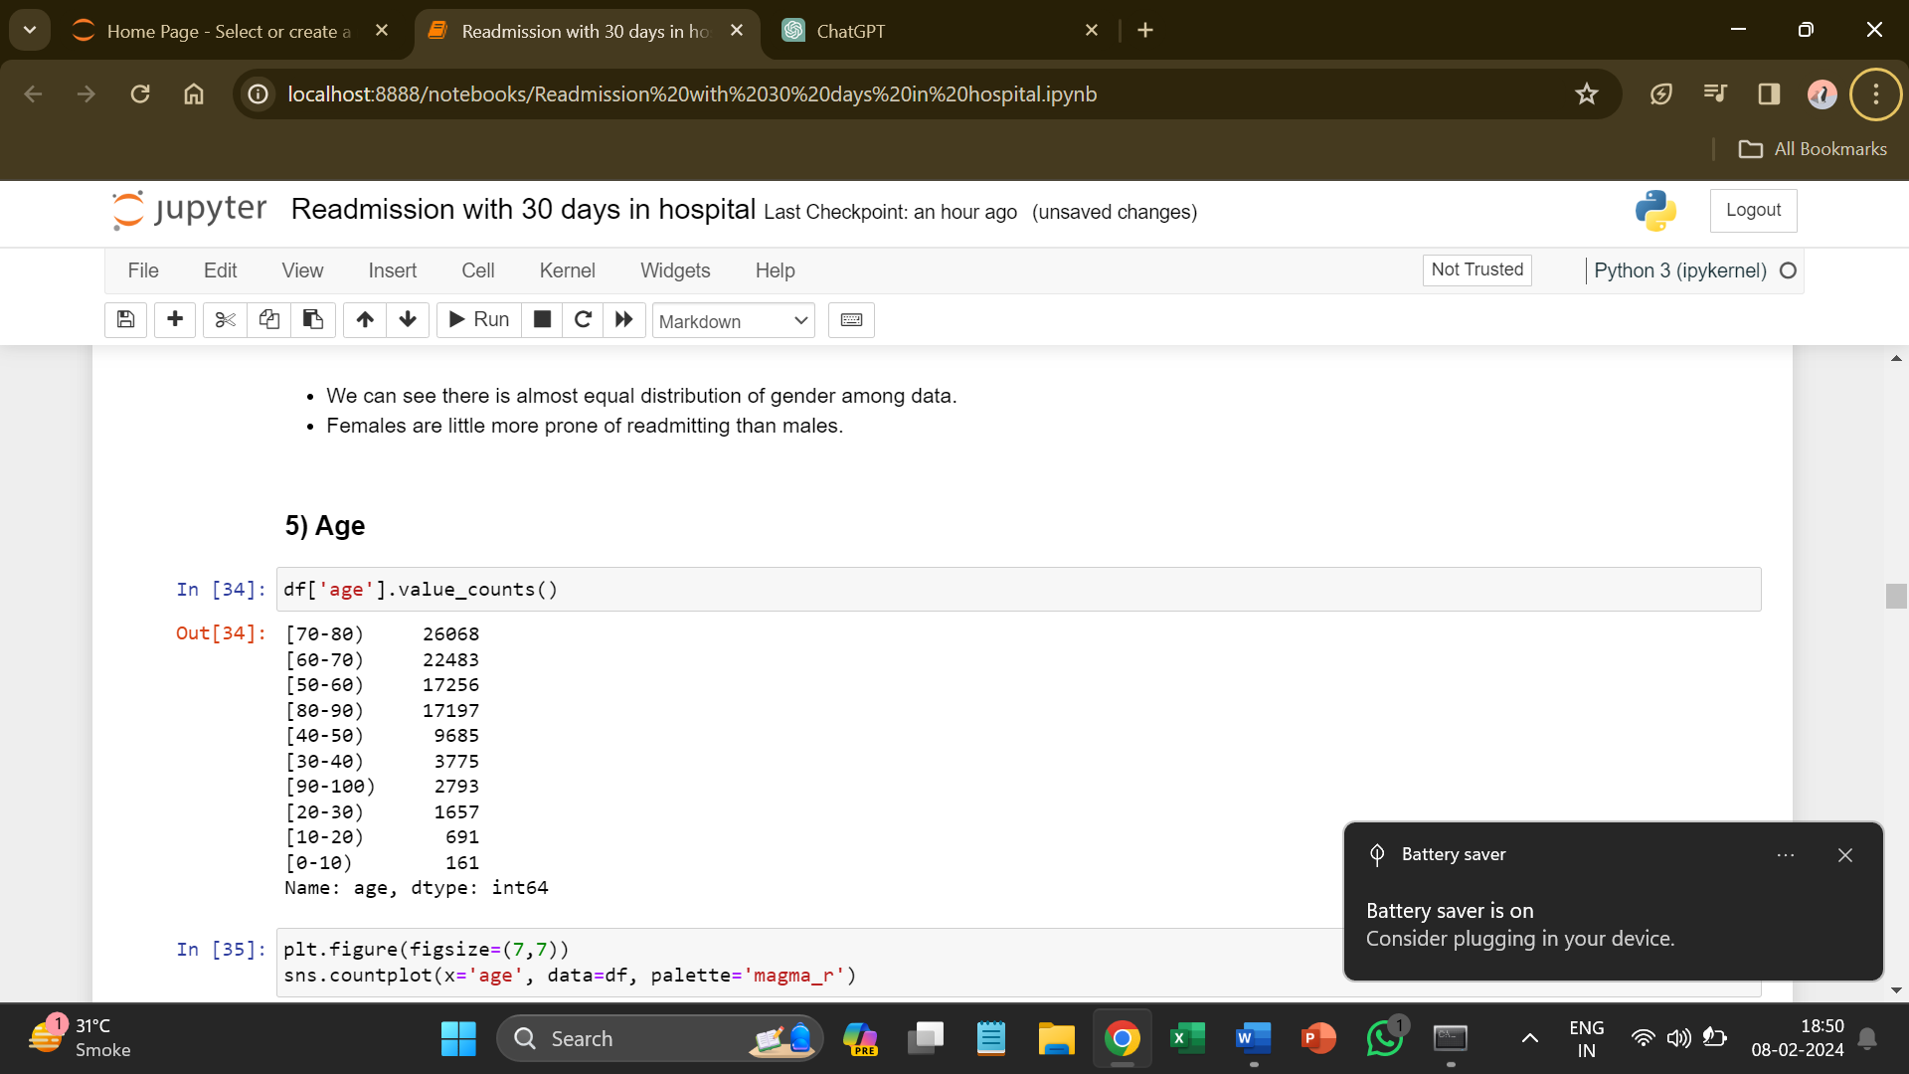

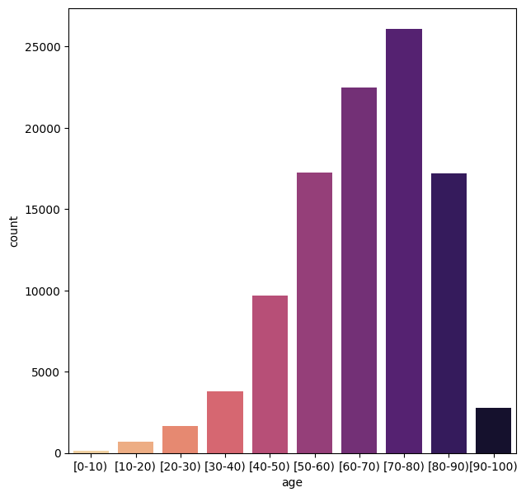

* The range of age is between **0 to 100.**
* Most of the population are in range of **50 to 80**.
* The dataset only gives us age as **10-year intervals**, so we do not know exact age of patients.
* We assume age of the patient on average lies at the midpoint of age category. For e.g. if the patients age category is 40-50, then we assume age = 45years. So, we converted age categories to midpoints.

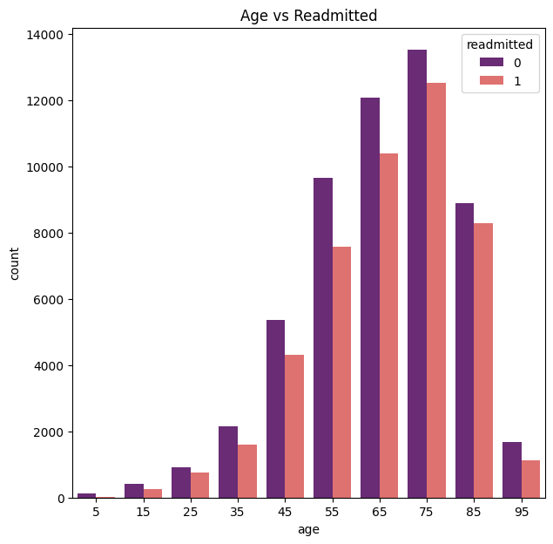

* The relationship of **older patients and readmission is strong** as mostly older patients are at high risk of readmission.
* And you can also see from the data the mostly older patient is readmitted, and younger people not tend to readmit.

1. **Weight**

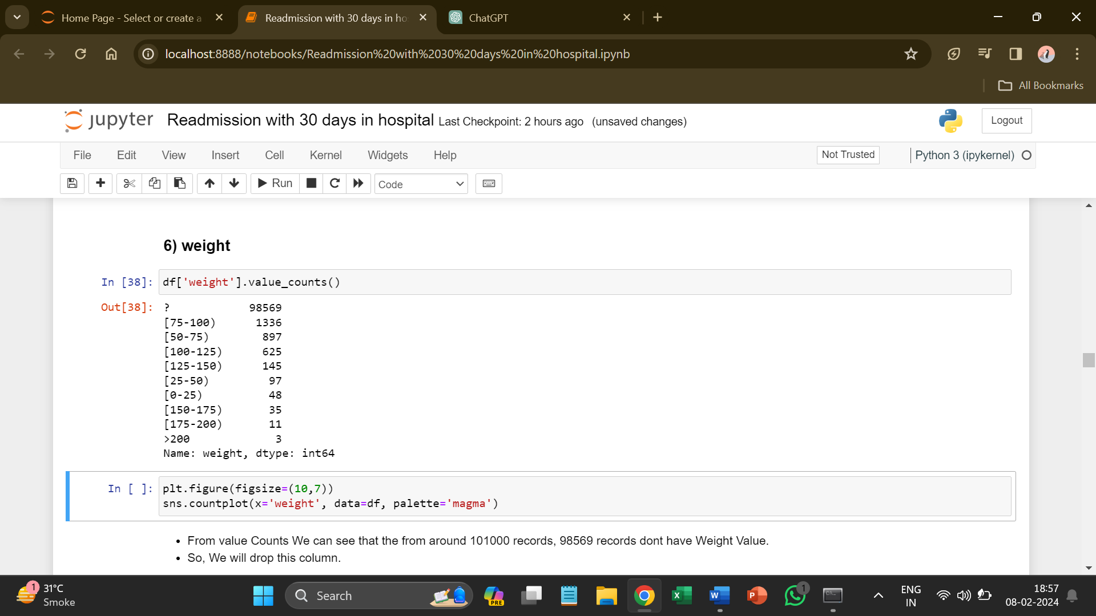

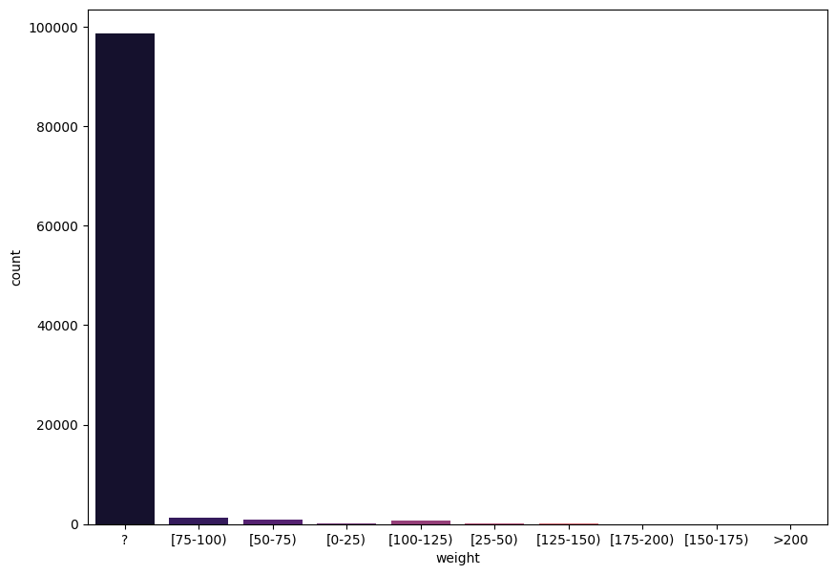

* From value counts we can see that the from around 101000 records, 98569 records do not have weight value.
* So, we will drop this column.

1. **admission_type_id**

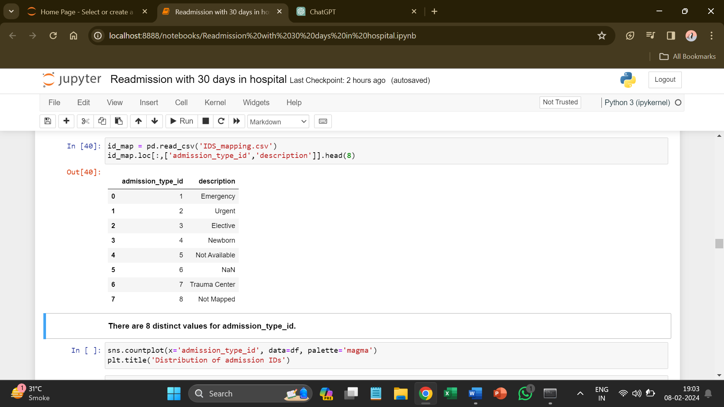

* There are **8 distinct values** for admission_type_id.

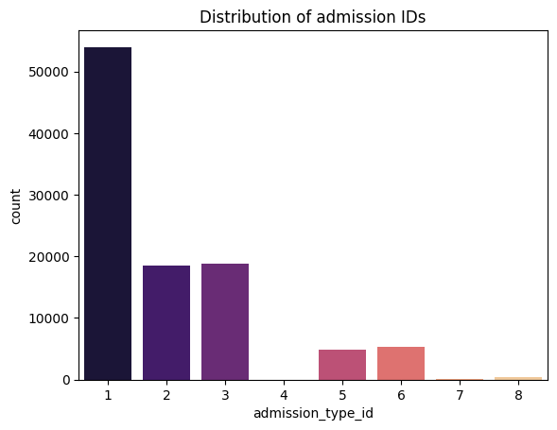

* We can see that, Id 1 that is **Emergency** has most encounters.
* As we can see that most of the cases that have been admitted to hospital have an admission type as **Emergency**.

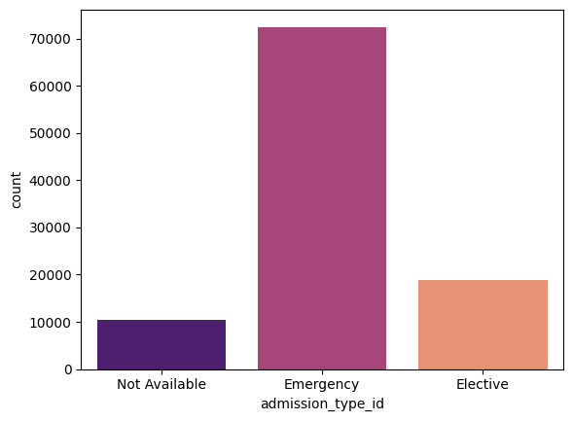

* If the patients have an encounter, then there is **high probability** of Emergency patients to get readmitted.

1. **discharge_disposition_id**

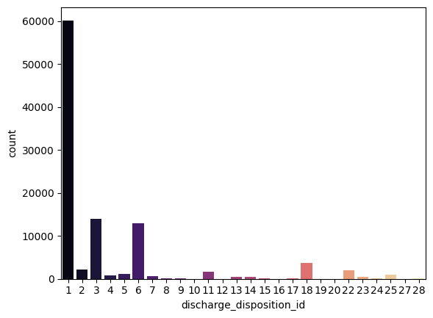

* There are 30 distinct values in the discharge_disposition_id.

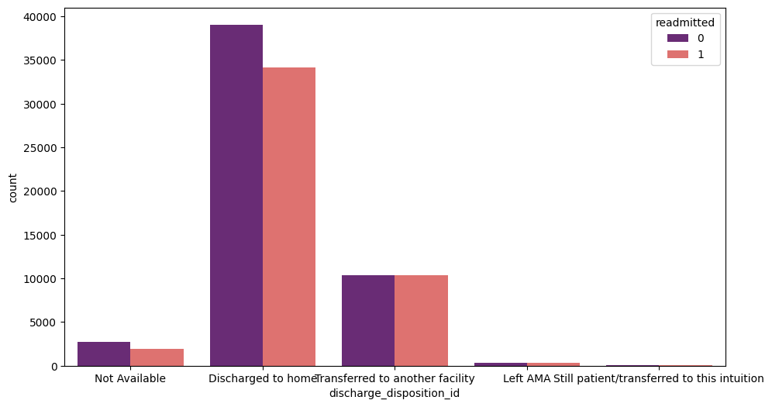

* The chances of getting readmitting are more for those who are discharged to home which is possible it can be because of age, other health related factors.

1. **admission_source_id**

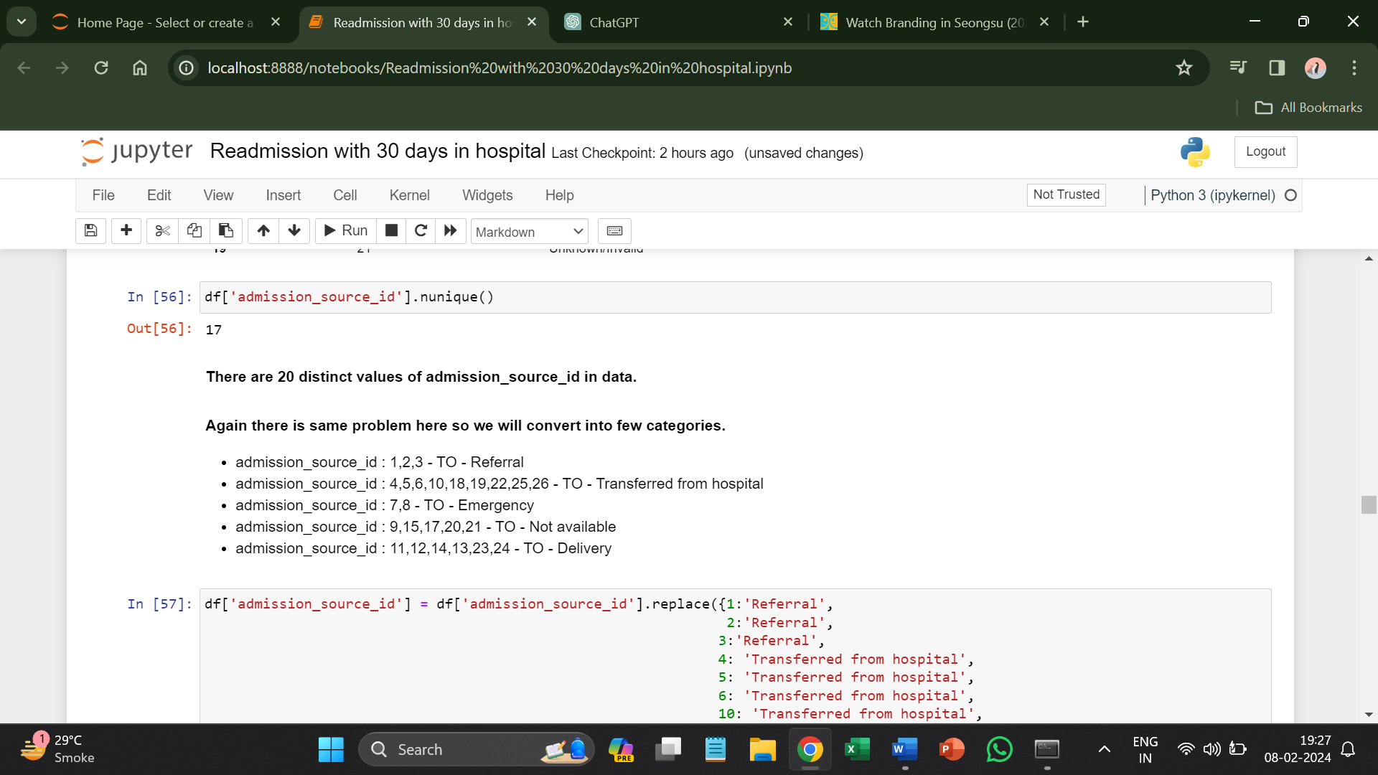

* There are **17** distinct values of admission_source_id in data.

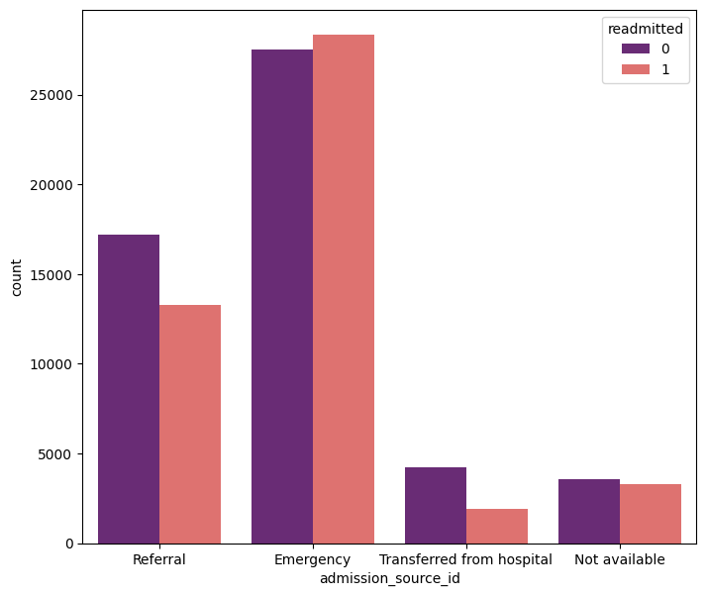

* Here also the chances of getting **readmitted** to hospital is more in Emergency cases.

1. **time_in_hospital**

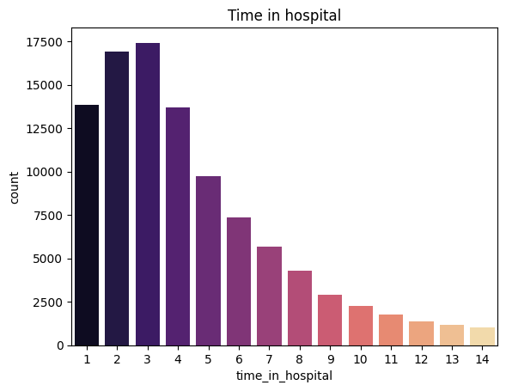

* Time in hospital ranges from 1 to 14 days.

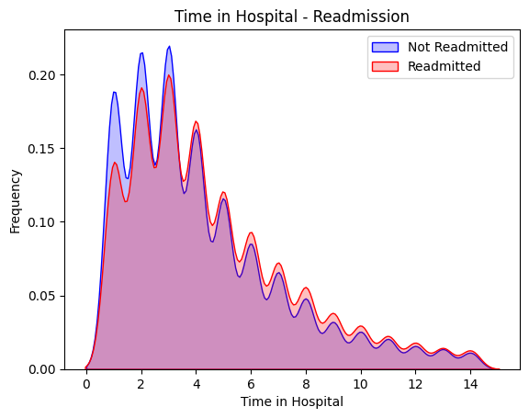

* The chances of getting readmitted is more for people those who have stayed in hospital between **2-4 days**.

1. **num_lab_procedures**

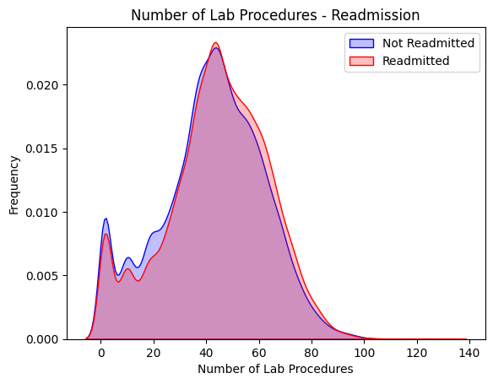

* The number of lab tests patient has undergone can range from **1 to 132**.
* The Distribution of Readmitted and Not Readmitted have the **same** trend.
* The number of labs procedures will not play a vital role in creating contrastive behaviour between Readmitted and Not Readmitted.

1. **num_procedures**

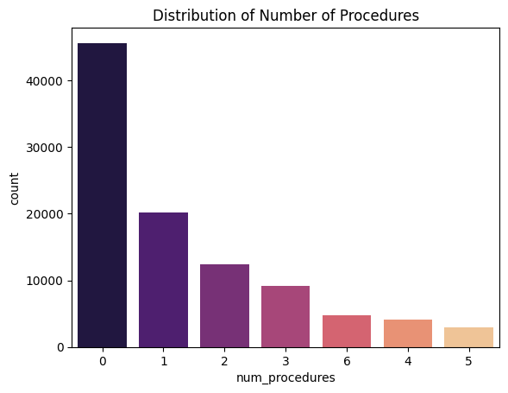

* The number of procedures ranges from 0 to 5.

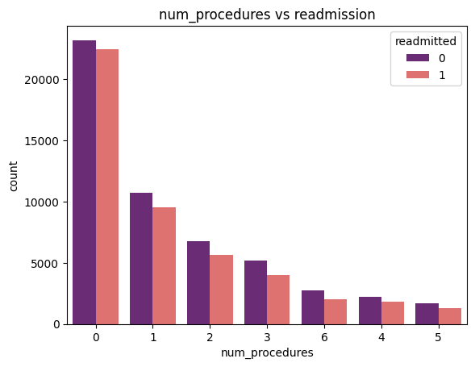

* Majority of people did not take the tests there is high chances of them getting readmitted.

1. **num_medications**

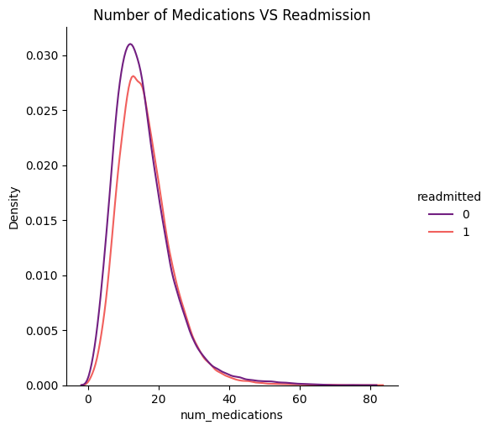

* The number of medication ranges from a minimum of 1 to maximum 81.
* Again, by looking at the distribution of Number of Medications a patient take, the trend look same for both classes.

1. **num_outpatient**

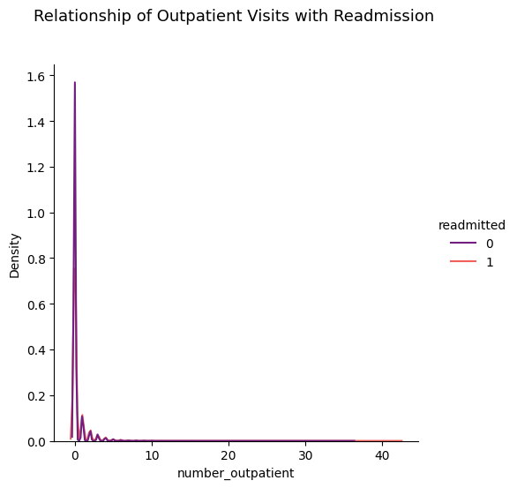

* The Distribution of Number of Outpatient is very skewed. We cannot understand the trend from here.
* As most of the patient have 0 inpatient visits.

1. **num_inpatient**

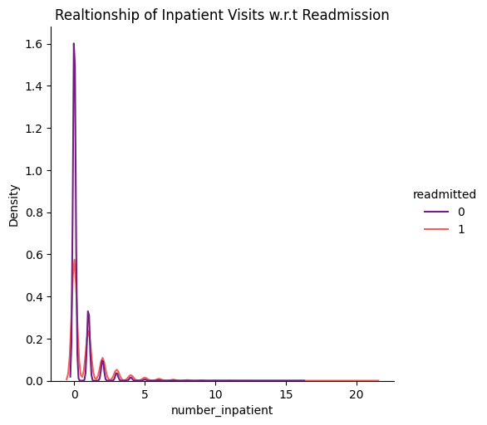

* We can see from above graph the inpatient readmission also lies at 0 for majority of patients.

1. **num_emergency**

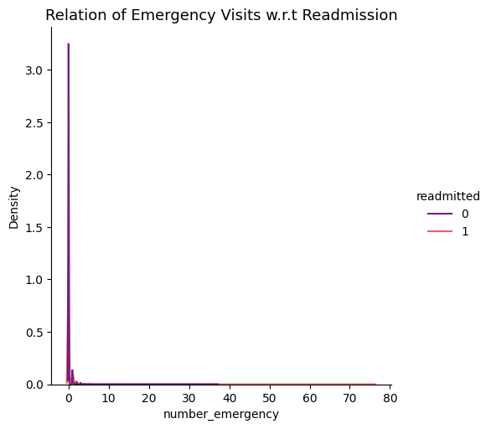

* We can see that the distribution of Emergency Visits very Skewed.
* Majority of the Patients have 0 Emergency Visits.

1. **diag_1, diag_2, diag_3**

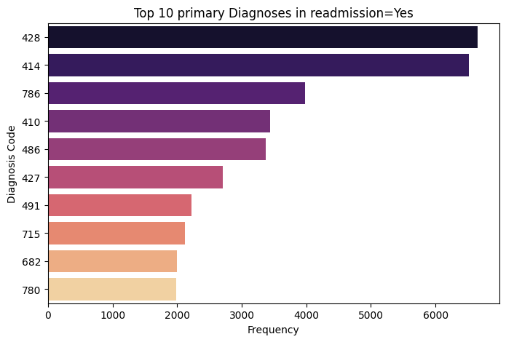

The Top Diagnosis Codes are 428, 414 and 786 in the Readmitted Patients. If we look at the ICD-9 Dictionary we will know that,

* 428 = Congestive heart failure
* 414 = ischemic heart disease
* 786 = Symptoms involving respiratory system and other chest symptoms
* 486 = Pneumonia, organism unspecified

So, Patients with Heart Disease and Chest Disease are more likely to readmit to the hospital.

1. **num_diagnosis**

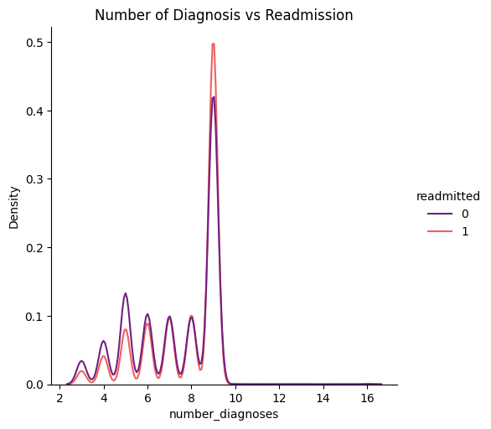

* From Above plot we can see that, there is no clear difference in people Readmitted and Not Readmitted.
* There is some minor difference, which is at where diagnosis between 8-10, The patient more likely to readmit.

1. **max_glu_serum**

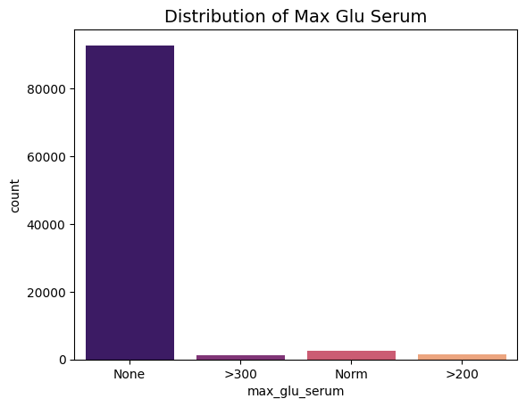

* None means the max_glu_serum test is not taken and almost 94,000 patients did not take this test.
* Let us, analyse the trend of this for other 3 values with respect to Readmission.

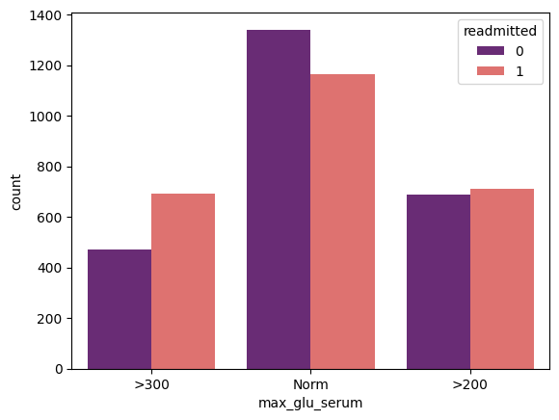

* We can see that if the value of max_glu_serum greater than 300 there is high chance of readmission as per the above graph.

1. **A1C result**

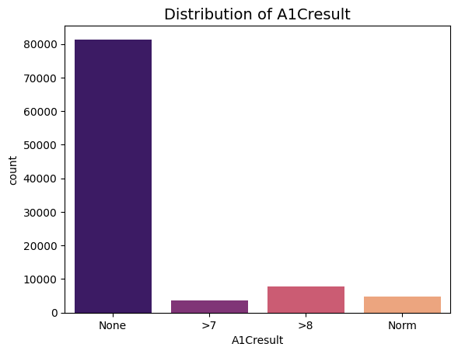

* Majority of the patients have None values, means this parameter if not measured.

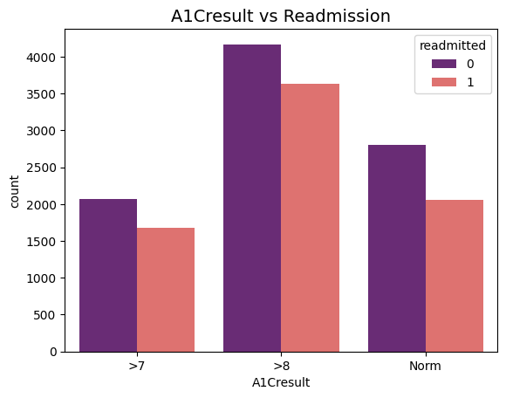

* There are more values for Not Readmitted in each category.
* The chances of getting more is in if the value of A1c result is more than >8.

1. **Change**

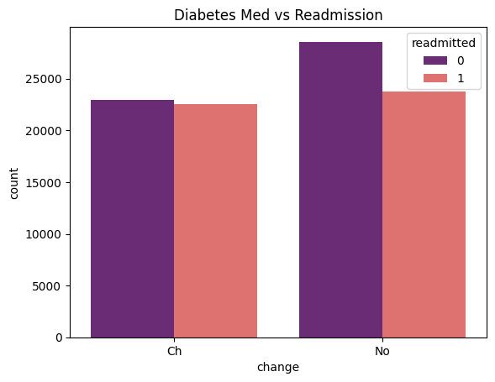

* Here we can see almost equal distribution for readmission and the values of not being readmitted is more.

1. **DiabetesMed**

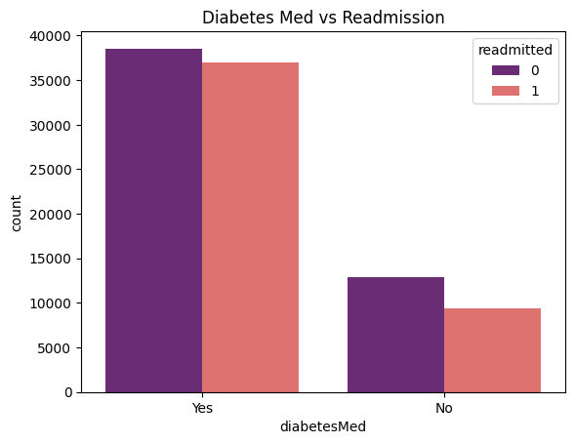

* From above figure we can see that, the patient with diabetes is the higher risk of getting readmitting.

1. **Medicines**

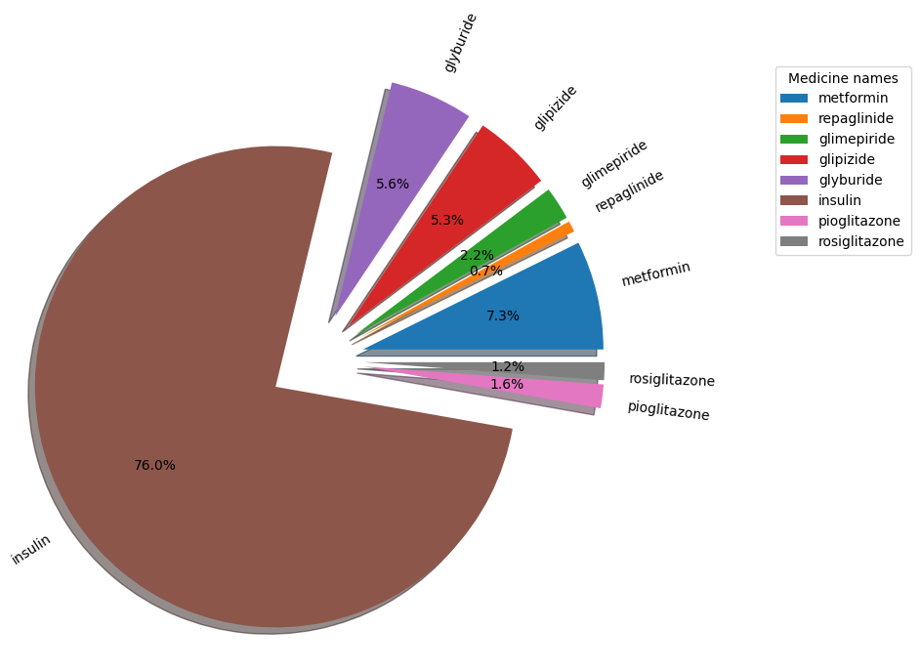

* Clearly, of all the encounters where dosage was increased, Insulin has most of the cases (76.1%), followed by Metformin. There are many medicines whose dosage were not increased, not even in a single case.
* **Transforming the Categorical Features**

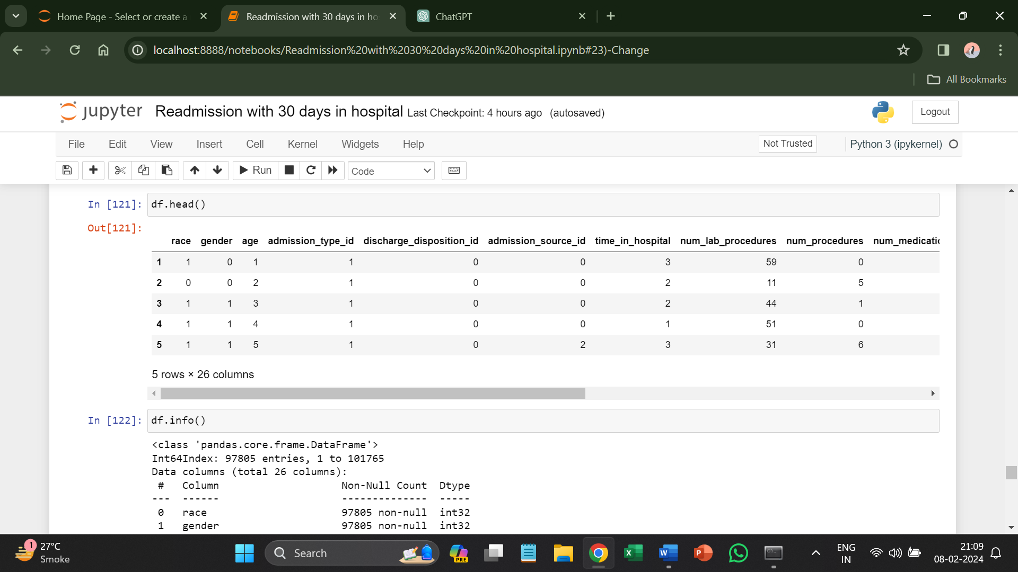

* Using the Label Encoding all columns have been converted into integers.
* **Splitting the dependent and independent variables**

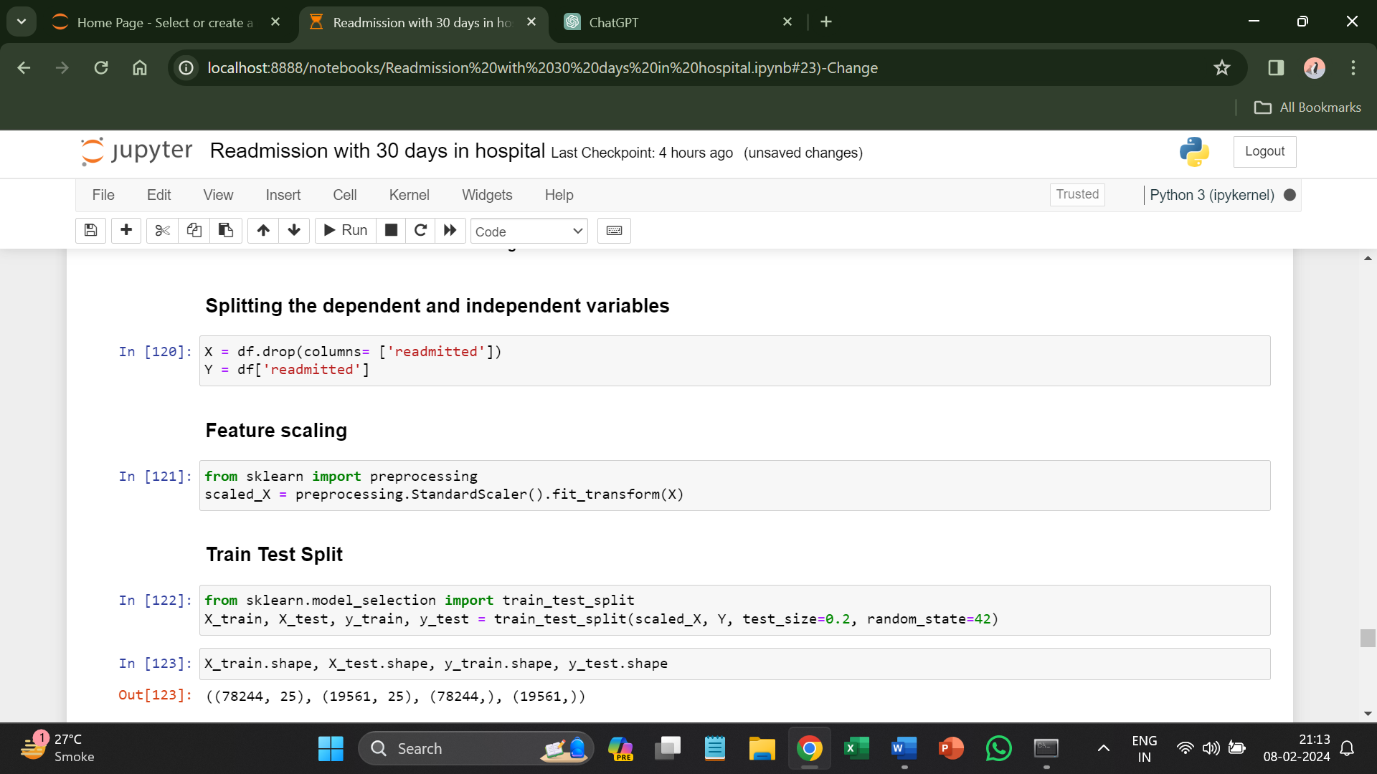

* Since, the target variable is readmitted so assigning it to Y.
* **Feature Scaling**
* Feature scaling using StandardScaler is a common preprocessing technique in machine learning to standardize the range of independent variables or features in the dataset.
* StandardScaler transforms the data such that its distribution will have a mean of 0 and a standard deviation of 1.



* fit_transform() method is used to compute the mean and standard deviation of each feature in the training set and then standardize the data.
* transform() method is used to apply the same transformation to the test set using the mean and standard deviation computed from the training set.
* **Train Test Split**



* **Creating machine learning model**

1. **Logistic Regression**

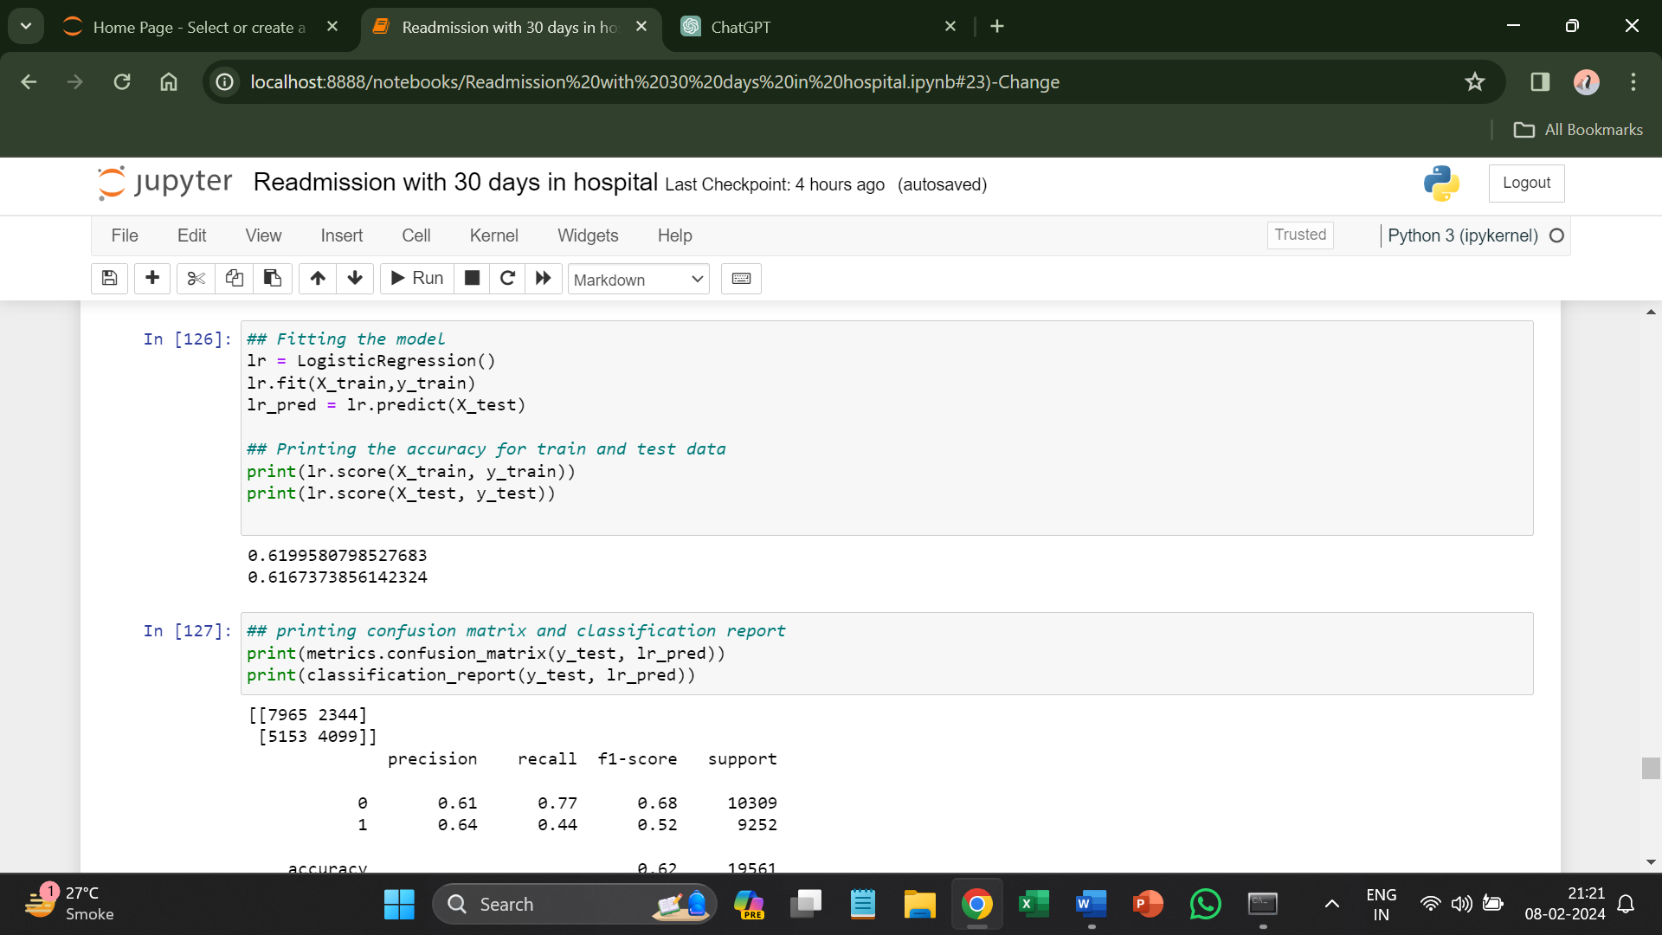

Confusion matrix and classification report

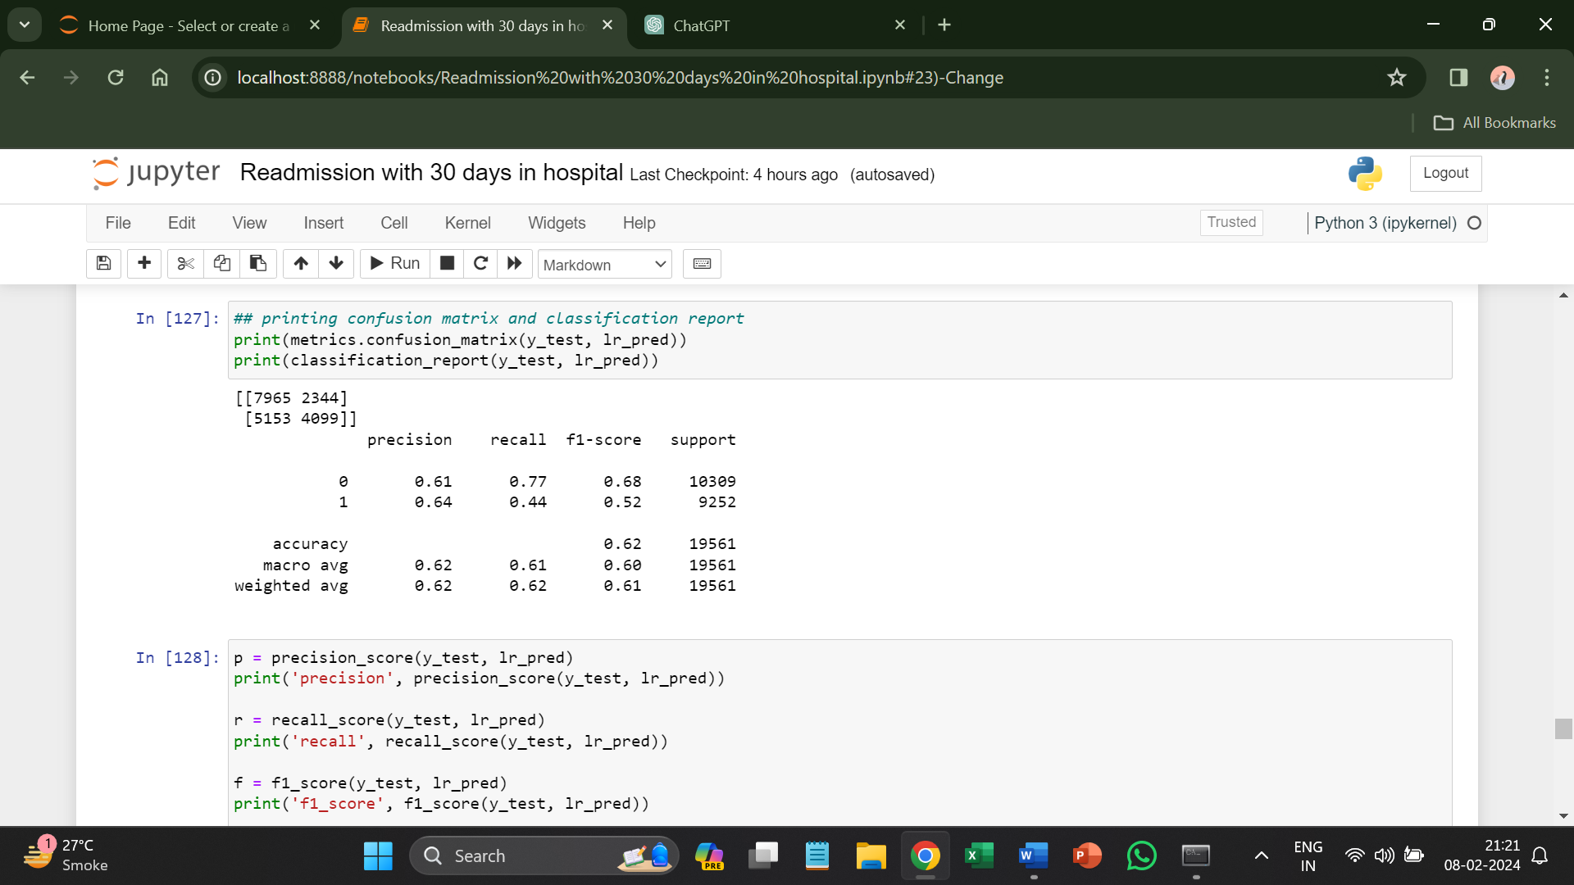

ROC AUC Curve

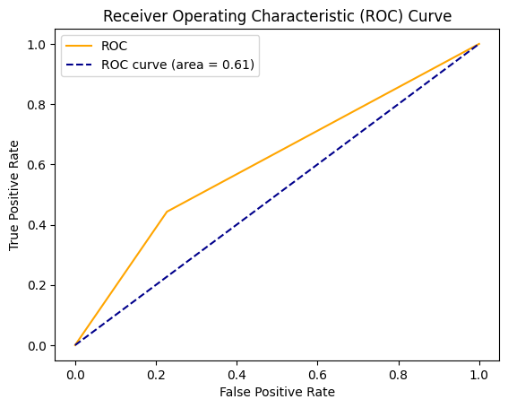

1. **Random Forest**

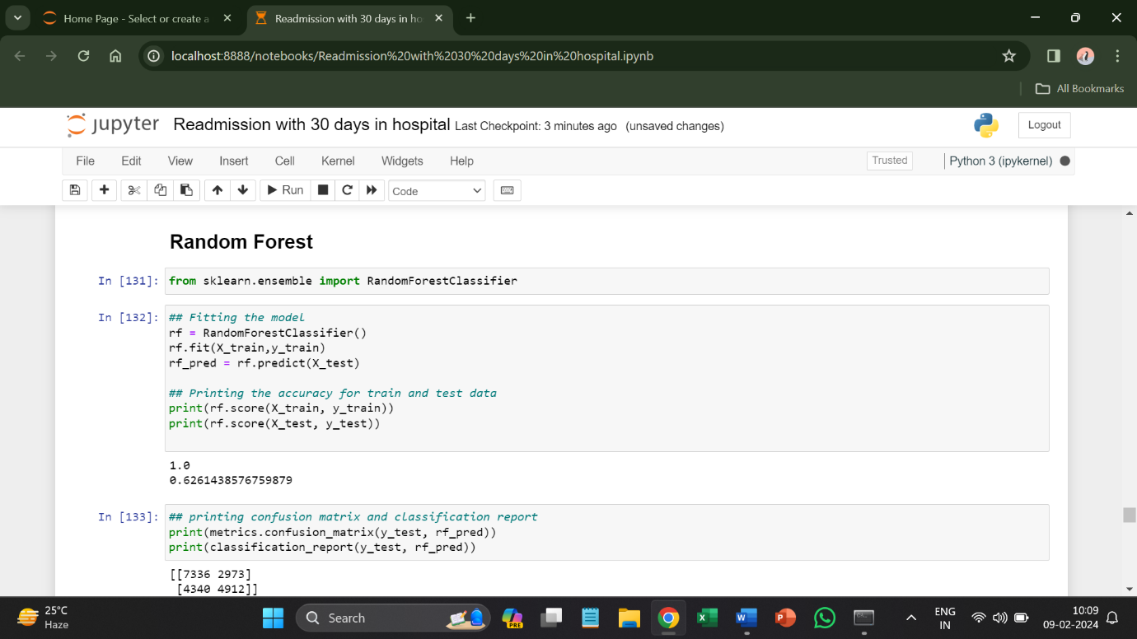

Confusion matrix and classification report

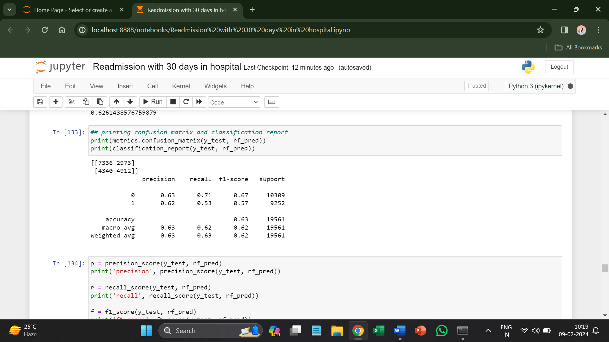

ROC AUC Curve

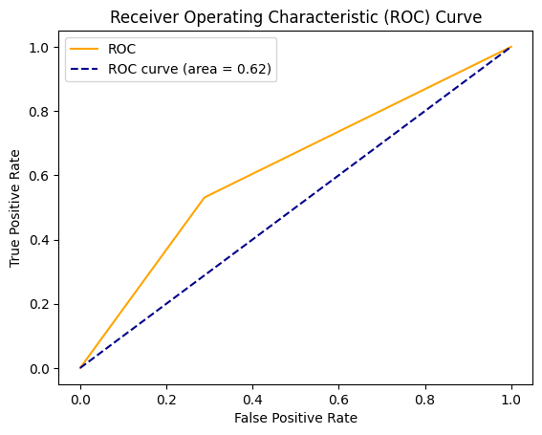

1. **Gradient Boosting Classifier**

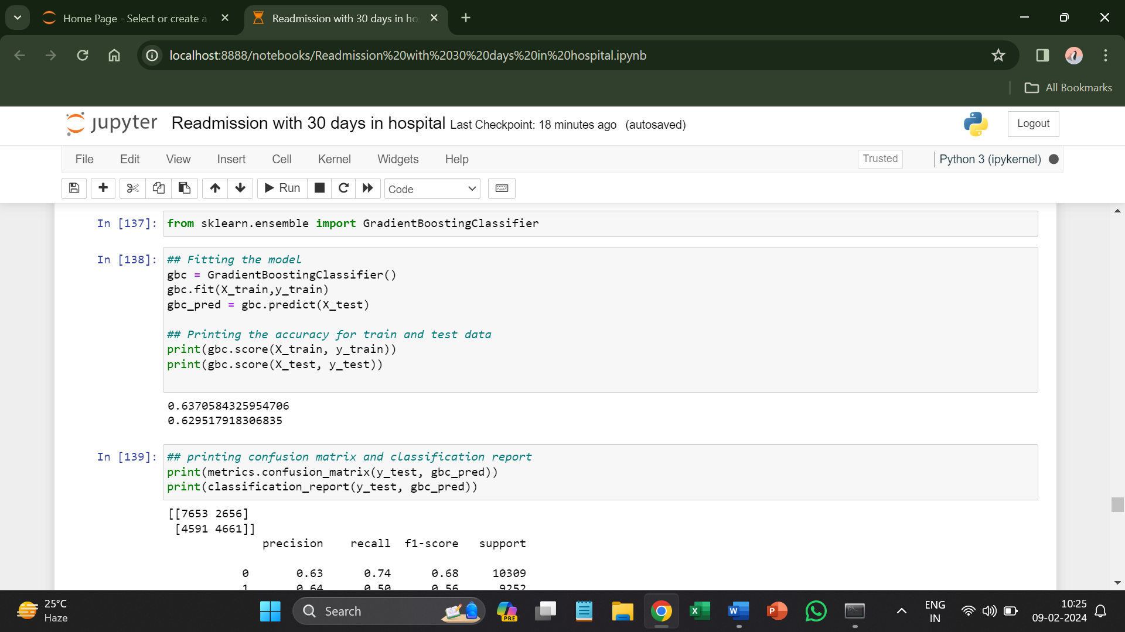

**Confusion matrix and classification report**

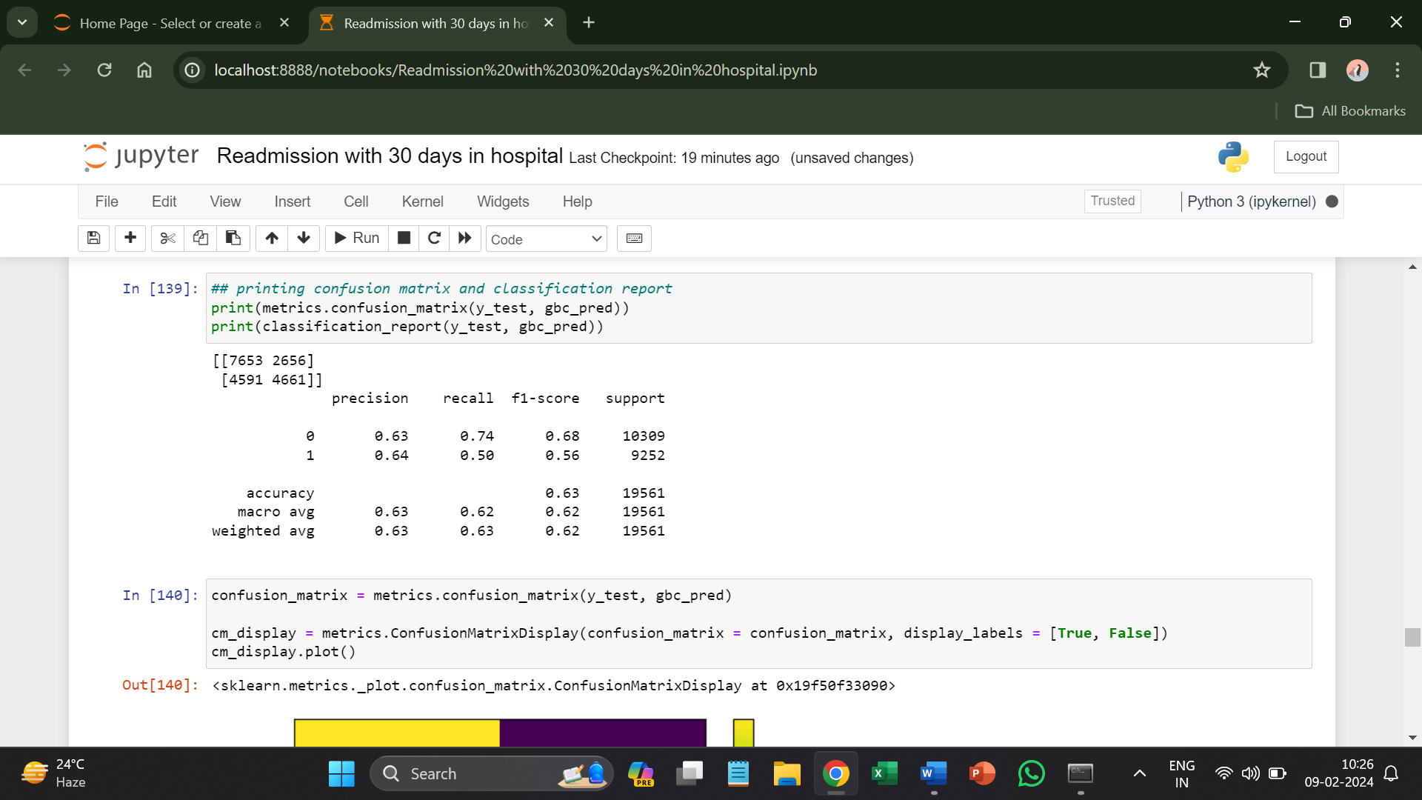

**ROC AUC Curve**

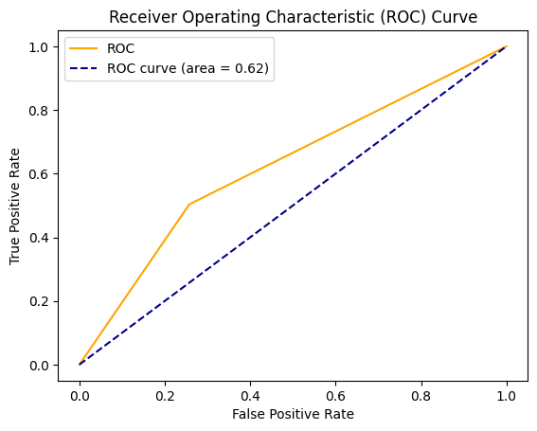

1. **XG Boost Classifier**

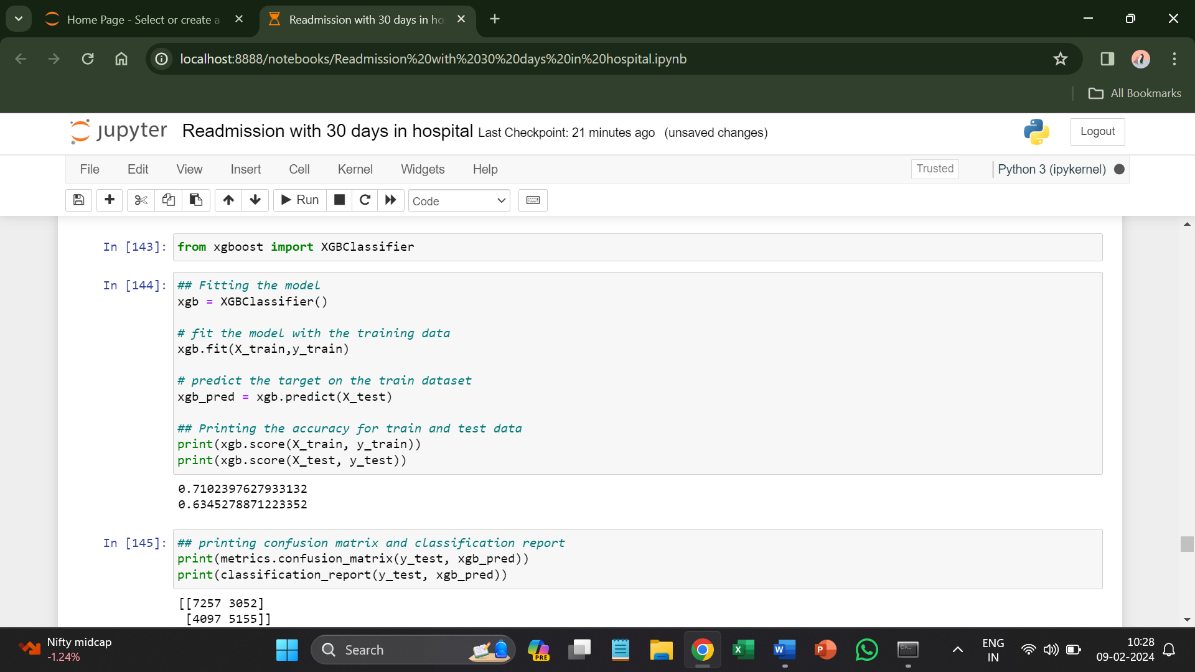

**Confusion matrix and classification report**

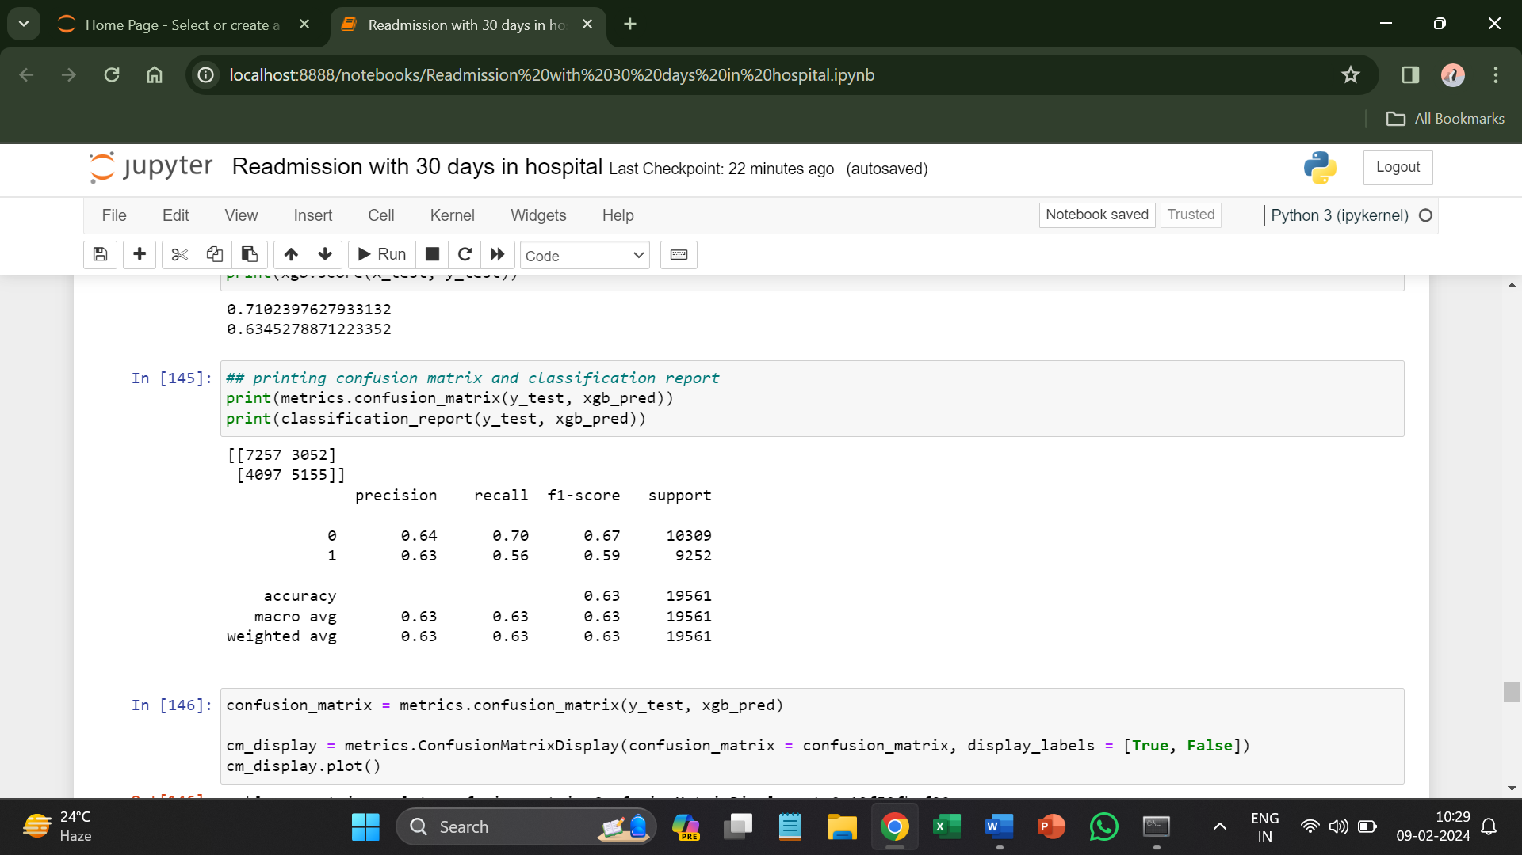

**ROC AUC Curve**

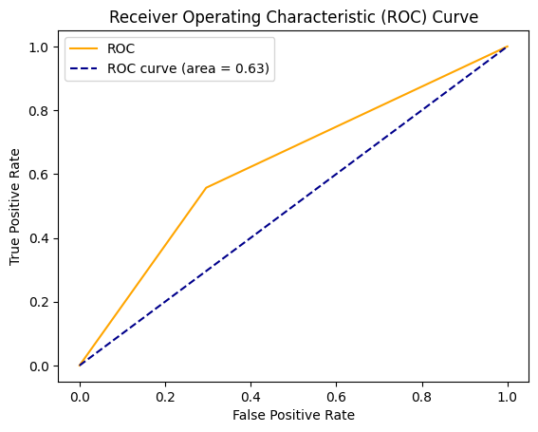

1. **LightGBM Classifier**

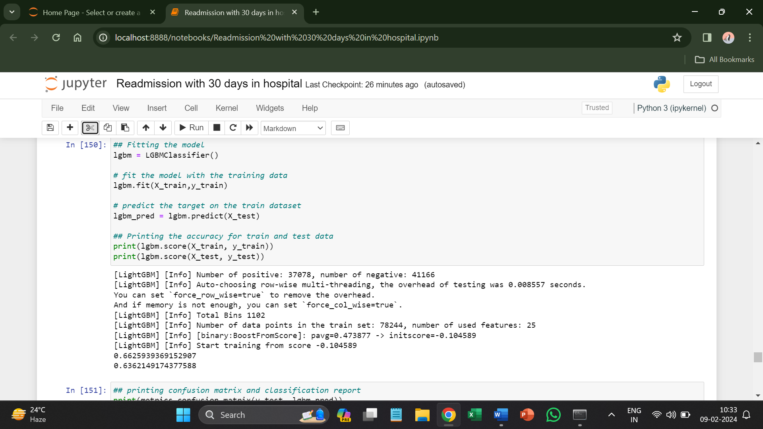

**Confusion matrix and classification report**

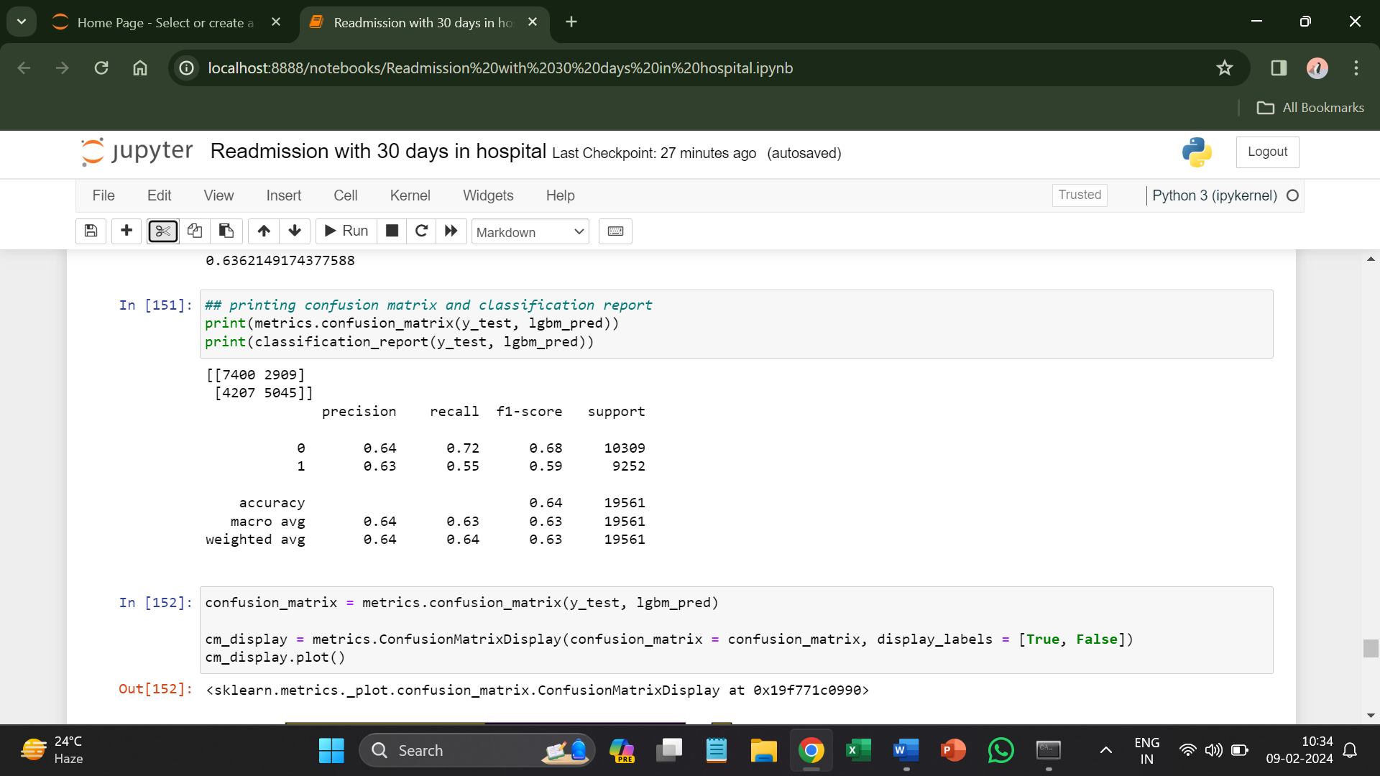

**ROC AUC Curve**

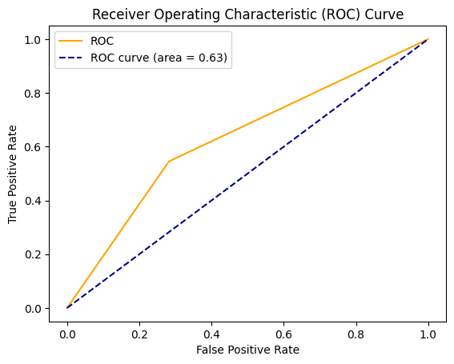

Since the LightGBM and XGBoost are performing better on data then baseline model so tuning them to see if the accuracy will increase or not.

* **Hyperparameter Tuning**

**Light GBM Tuning Model**

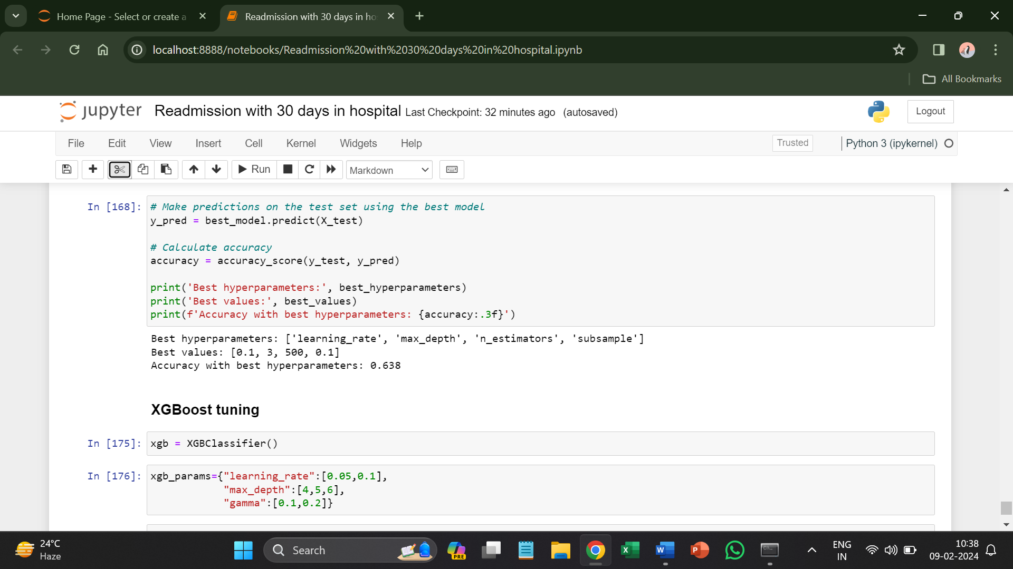

After tuning the model, the accuracy is 64% which is lesser than 66% so it is safe to say that with hyperparameter tuning the accuracy has not gotten any better.

**XGBoost Tuning Model**

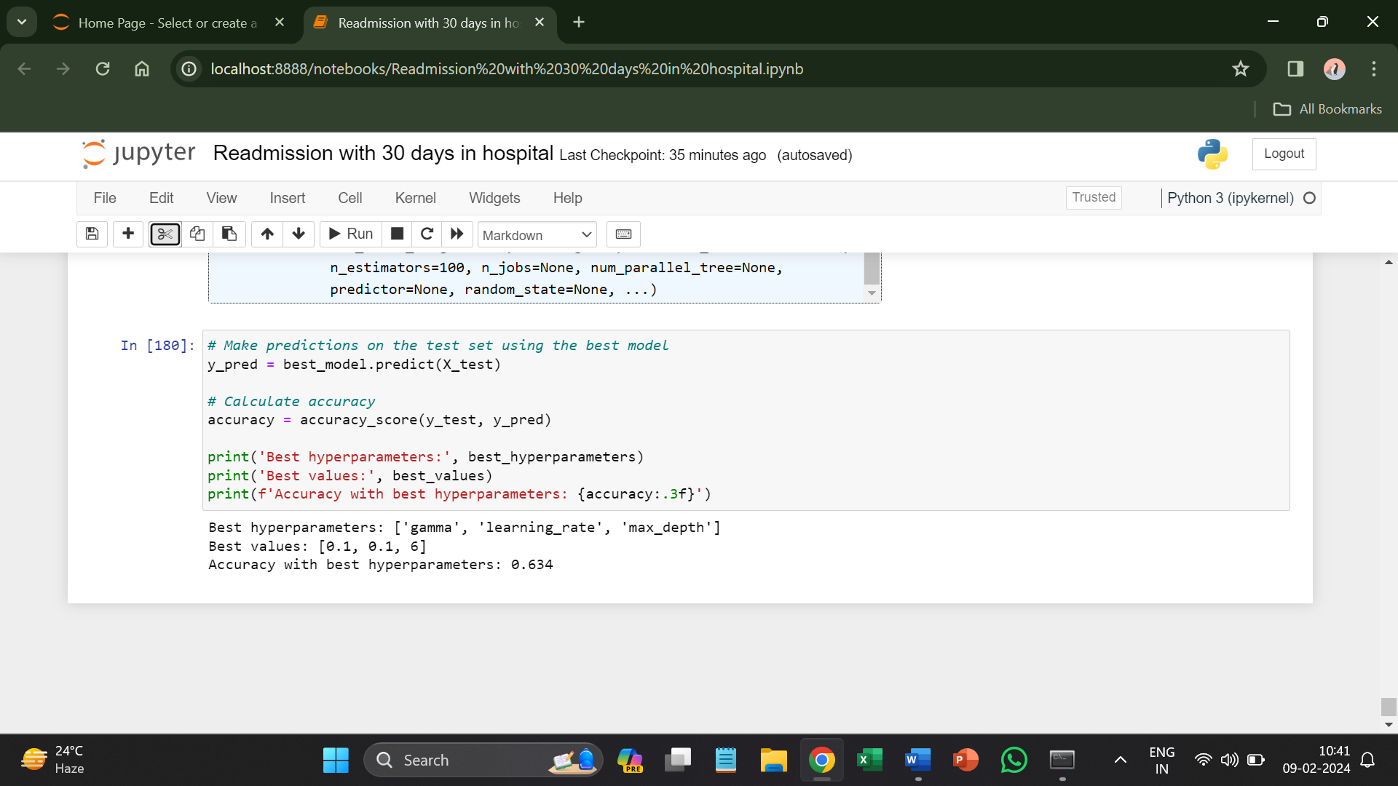

For XG Boost also the accuracy did not increase as 63% is way lesser than 71% so, here also the hyperparameter tuning did not help accuracy to increase.